**ASIA PACIFIC INSTITUTE OF INFORMATION TECHNOLOGY**





**Group Assignment**

**Members**

DILKI MEGAH DELGODA (**CB008338**)

KURUKULASOORIYAGE SIDUJA SASMITHA PERERA (**CB008484**)

FAIZAR ALI MOHAMMAD YAHYA (**CB008496**)

MEEGASTENNA GAMARALALAGE AVISHKA DIMAL SENANAYAKE (**CB007077**)

**Module Code & Title**

COMP50001

Commercial Computing

LEVEL 5

**Cohort:** IF2161SE

**Date of Submission:**

16th November 2021

**Instructor:**

Ms. Tharanga Peris

**Word Count: 5794**

|  |  |  |
| --- | --- | --- |
| **MARKING CRITERIA** | **%** | **MARKS OBTAINED** |
|  |  |  |
|  |  |  |
|  |  |  |
|  |  |  |
|  |  |  |
| **TOTAL (%)** | |  |

# Abstract

For this assignment, we are given the task to create a job seeking website as a team with the utilization of AGILE project management methodologies in 3-week SPRINTS. Throughout these Sprints, we are to develop and create functionalities by our set group roles per sprint of the website that are important for the project goal.

The website itself is developed with the utilization of the CodeIgniter 4 framework along with web development languages such as PHP, HTML, JavaScript and CSS for its design and responsive design. As for database functionality, phpMyAdmin was utilized with the use of XAMPP control panel for the web server.

# Table of Contents

Contents

Abstract 2

Table of Contents 3

Table of Figures 5

Work-Load Matrix 7

• Sprint 1 Team Roles 7

• Sprint 1 Tasks 7

Introduction 8

Project Charter 9

Work Breakdown Structure 13

Sprint Goal 14

Description: 14

Sprint Goal: 14

Functions Carried Out 15

Gannt Chart 16

16

Arrow on Arrow Diagram 17

17

Details: 18

Arrow on Node Diagram 19

High Level Use Case Diagram 20

Activity Diagrams 21

Applicant Registration Activity Diagram 21

Applicant Login Activity Diagram 22

Company Registration Activity Diagram 23

Company Login Activity Diagram 24

Admin Login Activity Diagram 25

Company Delete Job Advert 26

Company View Adverts 27

Company Add New Job Advert 28

Applicant View Job Advert 29

Implementation 30

• Implementation (Migrations) 31

• Implementation (Database Connections) 33

• Implementation (Models) 34

• Implementation (Views) 35

• Implementation (Controller) 48

Interfaces 58

• Wireframes 58

Landing Page 58

Registrations Page 60

Login Page 62

Applicant Home Page 64

Company Home Page 66

Admin Home Page 68

Company View Advert 70

Company Create Job Advertisement 72

Applicant Jobs View Page 74

Test Cases 76

Sprint 1 Retrospective 82

• Avishka Senanayake (Sprint 1 Retrospective) – SCRUM Master 82

• Siduja Perera (Sprint 1 Retrospective) – Quality Assurance 83

• Mohammad Yahya (Sprint 1 Retrospective) - Developer 84

• Dilki Delgoda (Sprint 1 Retrospective) – Business Analyst 85

References 86

# Table of Figures

Figure 1. Sprint 1 Team Roles 7

Figure 2. Sprint 1 Tasks 7

Figure 3. Work Breakdown Structure Diagram 13

Figure 4. Gannt Chart 16

Figure 5. AOA Diagram 17

Figure 6. Arrow on Node Diagram 19

Figure 7. High Level Use Case Diagram 20

Figure 8. Applicant Registration Activity Diagram 21

Figure 9. Applicant Login Activity Diagram 22

Figure 10. Company Registration Activity Diagram 23

Figure 11. Company Login Activity Diagram 24

Figure 12. Administrator Login Activity Diagram 25

Figure 13. Company Delete Job Advert 26

Figure 14. Company View Adverts 27

Figure 15. Company Add New Job Advert 28

Figure 16. Applicant View Job Advert 29

Figure 17. Registrations Table Migration 31

Figure 18. Adverts Table Migration Code 32

Figure 19. Connection to Adverts Database 33

Figure 20. Connection to Registrations Database 33

Figure 21. Registrations User Model 34

Figure 22. Adverts User Model 34

Figure 23. Landing Page Code 35

Figure 24. Login Page Code 36

Figure 25. Registrations Page Code 37

Figure 26. Applicant Home Page Code 38

Figure 27. Applicant Home Page Career advice cards 39

Figure 28. Company Home Page code 40

Figure 29. Admin Homepage / Dashboard 41

Figure 30. Company Create Adverts 43

Figure 31. Applicant Jobs Code. 44

Figure 32. Company View Ads 45

Figure 33. Admin View Ads. 46

Figure 34. Admin View All Users. 47

Figure 35. Login Controller 49

Figure 36. Home Controller 50

Figure 37. Jobs Controller 51

Figure 38. Postings Controller 53

Figure 39. Createad Controller 54

Figure 40. Admin. php 57

Figure 41. Landing Page (Wireframe) 58

Figure 42. Landing Page Interface 59

Figure 43. Registration Page (Wireframe) 60

Figure 44. Registrations Page Interface 61

Figure 45. Login Page (Wireframe) 62

Figure 46. Login Page Interface 63

Figure 47. Applicant Home Page (Wireframe) 64

Figure 48. Applicant Home Page Interface 65

Figure 49. Company Home Page (Wireframe) 66

Figure 50. Company Home Page Interface 67

Figure 51. Admin Home Page (Wireframe) 68

Figure 52. Admin Home Page Interface 69

Figure 53. Company View Advertisement (Wireframe) 70

Figure 54. Company View Job Advertisement Interface 71

Figure 55. Company Create Job Advertisement (Wireframe) 72

Figure 56. Company Create Job advertisements Interface 73

Figure 57. Applicant Jobs View Page (Wireframe) 74

Figure 58. Applicant Jobs View Page Interface 75

# Work-Load Matrix

## Sprint 1 Team Roles

|  |  |
| --- | --- |
| **Sprint Role** | **Name** |
| SCRUM Master | Avishka Senanayake |
| Developer | M. Yahya |
| Business Analyst | Dilki Delgoda |
| Quality Assurance | Siduja Perera |

Figure 1. Sprint 1 Team Roles

## Sprint 1 Tasks

|  |  |
| --- | --- |
| **Task** | **Completed By** |
| Work Breakdown Structure | Avishka S. |
| Creating Gannt Chart | Avishka S. |
| Creating Arrow on Arrow Diagram (AOA) | Avishka S. |
| Creating Arrow on Node Diagram (AON) | Avishka S. |
| Sprint 1 Documentation | Avishka S. |
| Website Wireframes | Dilki D. |
| Webpage Design Conceptualization | Dilki D. |
| High Level Use Case Diagram | Dilki D. |
| Activity Diagrams | Dilki D. |
| Landing Page | M. Yahya |
| Registrations Page | M. Yahya |
| Login Page | M. Yahya |
| Home Pages | M. Yahya |
| Admin Dashboard / Home Page | M. Yahya |
| Admin Delete Accounts and Job Adverts | M. Yahya (Main) & Avishka S. |
| Applicant View Jobs | M. Yahya (Main) & Avishka S. |
| Company Post and View Job Advertisements | M. Yahya (Main) & Avishka S. |
| Registration and Login Testing | Siduja P. |
| Home Page Testing | Siduja P. |
| Creation of Test Cases | Siduja P. |

Figure 2. Sprint 1 Tasks

# Introduction

The goal of this assignment is to create a job seeking website named futureseekers.lk to provide a unique hiring experience for both job seekers looking for new opportunities, and businesses looking to fill open positions at their companies. With three identified sets of main users on the website itself, we are to create an experience that would make a hiring process more meaningful for the two main user types. Both users should be able to register and login to the website and companies to be able to post job advertisements to the site itself. As for the job seekers, they should be able to search and view jobs that companies have posted on the site itself and apply to ones that satisfy their needs.

The process of conducing this assignment is done with the utilization of AGILE development methodology in the span of 3 SPRINTS, each of which lasts for 3 weeks, and each team member switches roles between each SPRINT to get the maximum experience of this assignment and the modern workflow of how a project is brought to completion. The roles consist of, SCRUM Master, Developer, Business Analyst and Quality Assurance.

# Project Charter

* **Project Name:**
  + Futureseekers.lk – A website for a smoother and more streamlined hiring experience.
* **Project Background:** 
  + The Futureseekers website provides a more unique and streamlined hiring experience for both Job Seekers and Companies as most of the hiring process’ formalities will be done through the sites features.
* **Goals or Benefits:**
* An easier way to apply for available job openings along with the feature to search and filter for specific jobs that the ‘Applicant’ might be interested in.
* Online video interviews through the website itself provide a more streamlined interview process without the need for 3rd party applications and prior preparation with them.
* Live chat text functionality for prompt and quick connection between both Company and Applicant for quick communication with any queries or clarifications among either party.
* Notifications and updates for both user types to be more updated and alerted whenever changes might occur with their listing and hiring process.
* **Scope** 
  + **Technologies** 
    - For basic website design and responsive functionality HTML, CSS, JavaScript
    - CodeIgniter 4 PHP framework for the use of the MVC design pattern in development.
    - For free online webpage hosting, Heroku will be utilized.
    - For easier and hassle-free development with JavaScript, jQuery library will be used.
    - For more responsive website design and being compatible with multiple devices, Bootstrap 5 will be utilized.
  + **Purpose (Administrators)**
    - Profile verification of both Applicants and Companies after their accounts have been created.
    - Manage and view details of registered users on the site.
    - Generate reports and see which of the existing adverts on the site are popular and most engaged with.

* + **Purpose (Job Seeker)**
    - Filter, search, and view details of available job advertisements
    - Apply towards an interested job advertisement on the site itself.
    - Recommend existing job adverts on the site to their associates and colleagues.
  + **Purpose (Companies)**
    - Create and post job listings to the website to be seen by job seekers.
    - Notifications and updates whenever changes occur to their advertisements.
    - Report generation on posted advertisements for more through information.
* **Key Stakeholders (*PER SPRINT*)**

***Sprint 1***

|  |  |  |  |  |
| --- | --- | --- | --- | --- |
| **Tharanga P.**  Product Owner | **Avishka S.**  SCRUM Master | **Siduja P.**  Quality Assurance | **Dilki M.**  Business Analyst | **M. Yahya**  Developer |

***Sprint 2***

|  |  |  |  |  |
| --- | --- | --- | --- | --- |
| **Tharanga P.**  Product Owner | **Avishka S.**  Developer | **Siduja P.**  Business Analyst | **Dilki M.**  Quality Assurance | **M. Yahya**  SCRUM Master |

***Sprint 3 (Part 1)***

|  |  |  |  |  |
| --- | --- | --- | --- | --- |
| **Tharanga P.**  Product Owner | **Avishka S.**  Quality Assurance | **Siduja P.**  SCRUM Master | **Dilki M.**  Developer | **M. Yahya**  Business Analyst |

***Sprint 3 (Part 2)***

|  |  |  |  |  |
| --- | --- | --- | --- | --- |
| **Tharanga P.**  Product Owner | **Avishka S.**  Business Analyst | **Siduja P.**  Developer | **Dilki M.**  SCRUM Master | **M. Yahya**  Quality Assurance |

* **Project Milestones**

|  |  |
| --- | --- |
| **Milestones** | **Milestone Delivery Date** |
| Project Conceptualization | 6th September 2021 |
| Sprint 1 | 16th November 2021 |
| Sprint 2 | 14th December 2021 |
| Sprint 3 | TBD (2022) |
|  |  |
| Final Documentation / Release | Late January 2022 |

* **Constraints, Assumptions, Risks and Dependencies**
  + New technologies, coding languages and frameworks might have a learning curve when adapting to its development environment.
  + Scheduling and time related issues might arise when it comes to Sprint deliverables.
  + Certain members might not be proficient with research and web development skills.
  + For one user group’s functionality to be meaningful, the other user’s functions need to be running and working without issue.

Budgeting:

* For a usual Agile based project with the same team roles in the industry, most of the time the budgeting costs depends on the requirements set and the prioritization of the tasks to complete. Usually for the priority its calculated per difficulty towards bringing the task to completion, and the time it takes per week. In a burn down example, the average cost per person per hour as we multiply the cost of each resource by each person. *(Agile budgeting: How much will it cost? | Agilest, 2021)*

# Work Breakdown Structure

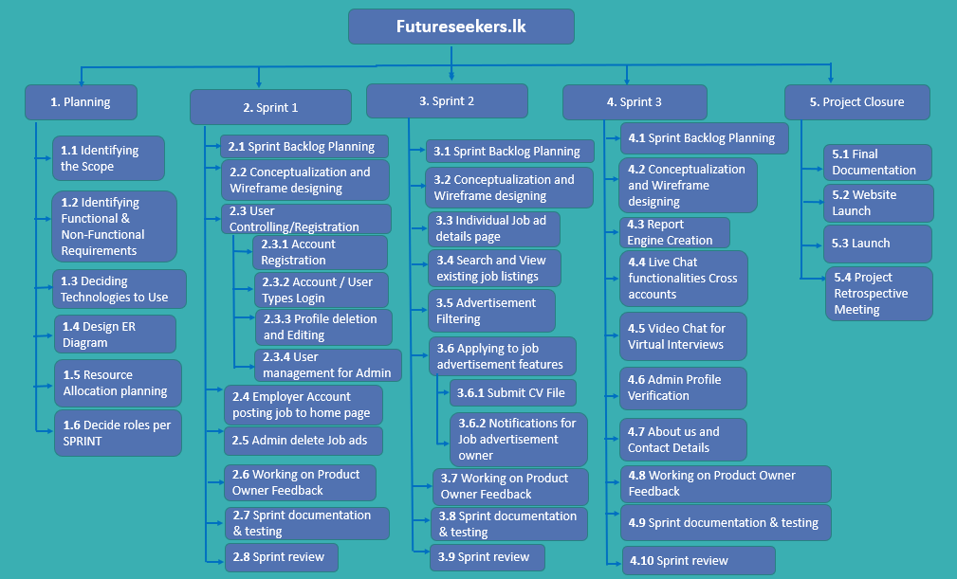

Figure 3. Work Breakdown Structure Diagram

# Sprint Goal

## Description:

As this was the first the first SPRINT of this assignment, the goal was to establish an entry point for the user base to use the features of the job seeking website itself. The first step of this was to establish a point for the user to create an account and list themselves as either an ‘Applicant’ or ‘Company’.

Post registration, they will be able to login to their relevant account and be redirected to the home page where the feature set will be tailored to their account type.

## Sprint Goal:

* Creating an entry point for the different types of users to use the website, along with a home page interface and basic job posting.
  + Create Registrations and Login
  + Job Posting
  + Home Page design per user
  + Basic Admin Controls
  + Company Account Job Posting

# Functions Carried Out

Since the goal of this Sprint was to establish an entry point for the website and its features and provide the first step towards job posting, the features are as follows.

* **Landing Functionality** – The User will be greeted with a page with two options for selecting either login or registration. If they already have an account existing, they will be able to login, if not go to the registrations page.
* **Registrations Functionality** – If a user does not have an existing account with the webpage, they will be able to enter their information and register an account.
* **Logins Functionality** - If the user has an account, they will be able to login to the website and use its features.
* **Home Page** - This is where each user will be landed to after logging in to their account. It will display a tailored experience depending on their account type.
* **Company Post Jobs** – Company accounts will be able to post jobs into the website where applicants will be able to view and see them. They can add title, category, and description.
* **Company Delete Jobs** – Once posted, the company can view and see the jobs that were posted and delete them if needed.
* **Admin User Management** – Admins will be able to see a grand view of all the users on the website and delete them accordingly so that the logins cannot be used again.
* **Admin Delete Adverts** – Admins will be able to see all the advertisements on the webpage and can delete them accordingly.

## Gannt Chart

## 

Figure 4. Gannt Chart

## Arrow on Arrow Diagram

## 

Figure 5. AOA Diagram

## Details:

|  |  |  |  |
| --- | --- | --- | --- |
| **Activity** | **Description** | **Proceeding Activity** | **Activity Time** |
| **A** | Sprint 1 Planning | - | 1 |
| **B** | Prioritized Backlog | A | 1 |
| **C** | Activity Diagrams Design | B | 2 |
| **D** | Use Case Diagrams Design | C | 1 |
| **E** | Wireframe Designs | C, D | 2 |
| **J** | Create Landing Page | E | 1 |
| **K** | Create Registrations Page | J | 2 |
| **L** | Create Login Page | K | 2 |
| **M** | Create Home Page | L | 4 |
| **N** | Employer Job Advert Posting | J, K, L, M | 3 |
| **O** | Admin Account – Delete Job Adverts | N | 3 |
| **P** | Admin User Management | K, M | 2 |
| **Q** | 1st Sprint Testing | O, P | 1 |
| **R** | 1st Sprint Documentation | Q | 1 |

## 

## Arrow on Node Diagram

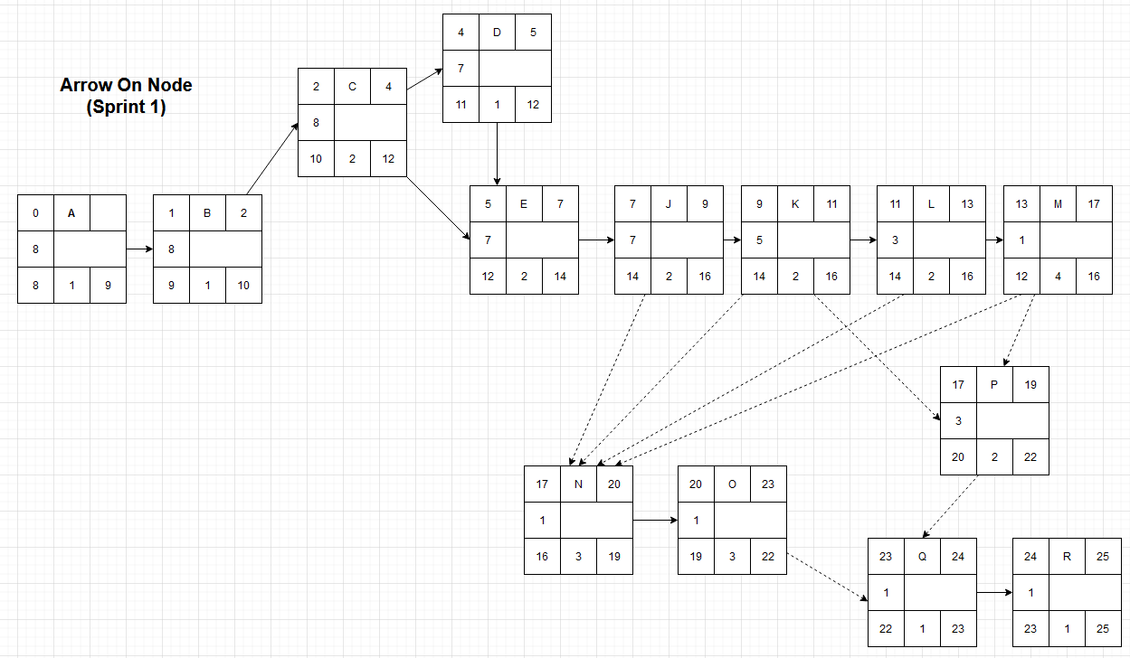

Figure 6. Arrow on Node Diagram

# High Level Use Case Diagram

* Sprint 1 high level use case diagram

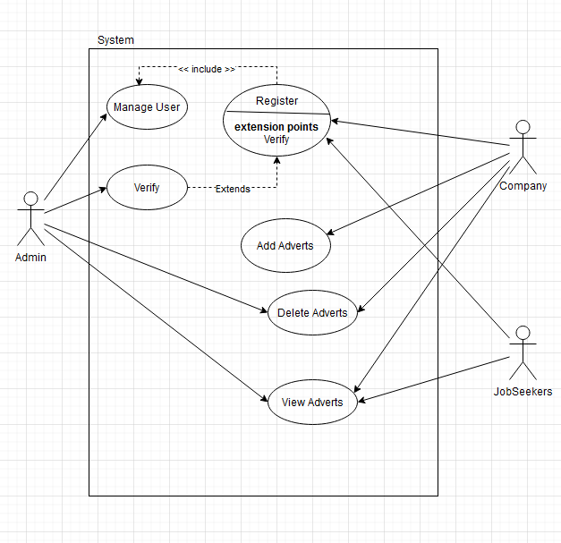

Figure 7. High Level Use Case Diagram

# Activity Diagrams

### Applicant Registration Activity Diagram

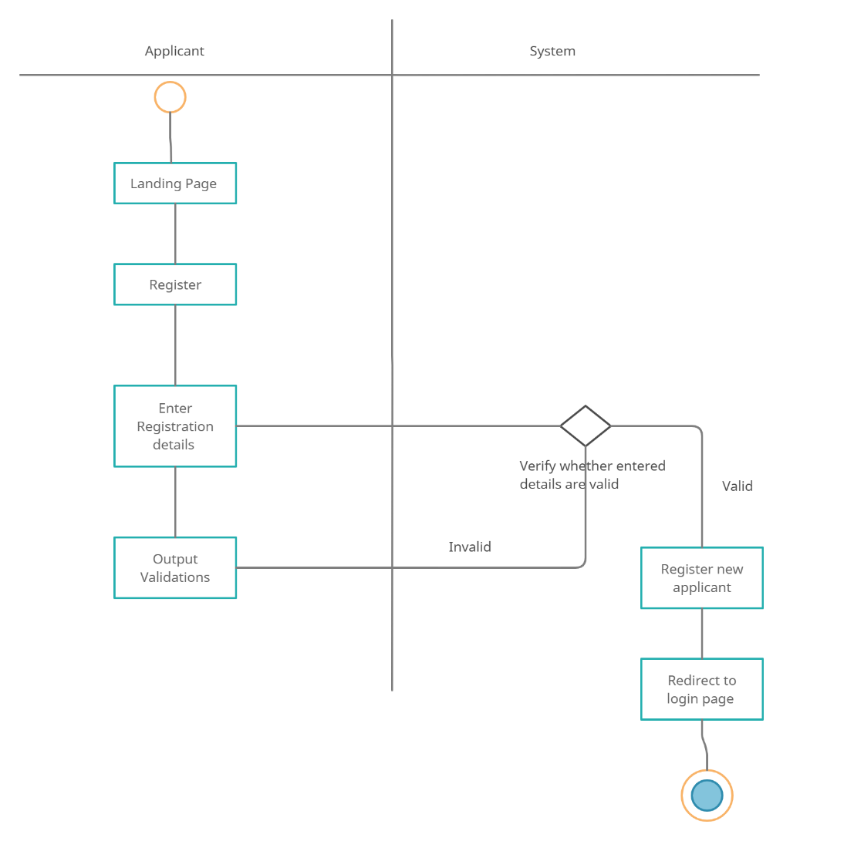

Figure 8. Applicant Registration Activity Diagram

For an applicant to register with an account after selecting the registration button from the landing page they will be sent to the registrations page where they will be asked for information, and it will be validated from the system. If all is according to order, the information will be added to the database and a new Applicant account is created.

### Applicant Login Activity Diagram

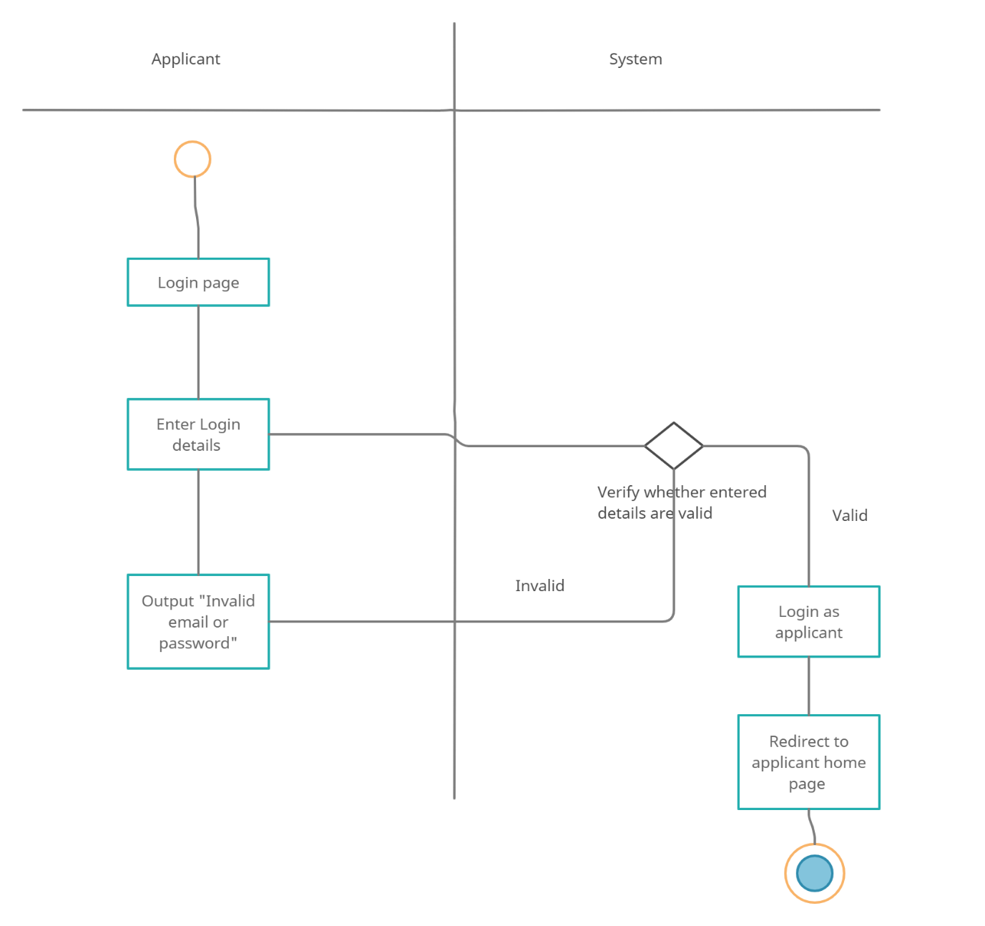

Figure 9. Applicant Login Activity Diagram

* For the applicant to login, they will be asked to enter their relevant account information, where then the information will be checked from the database if it is accurate and existing. If there is no issue, the user will be redirected to the home page. If not, they will be given a message that the entered information is invalid.

### Company Registration Activity Diagram

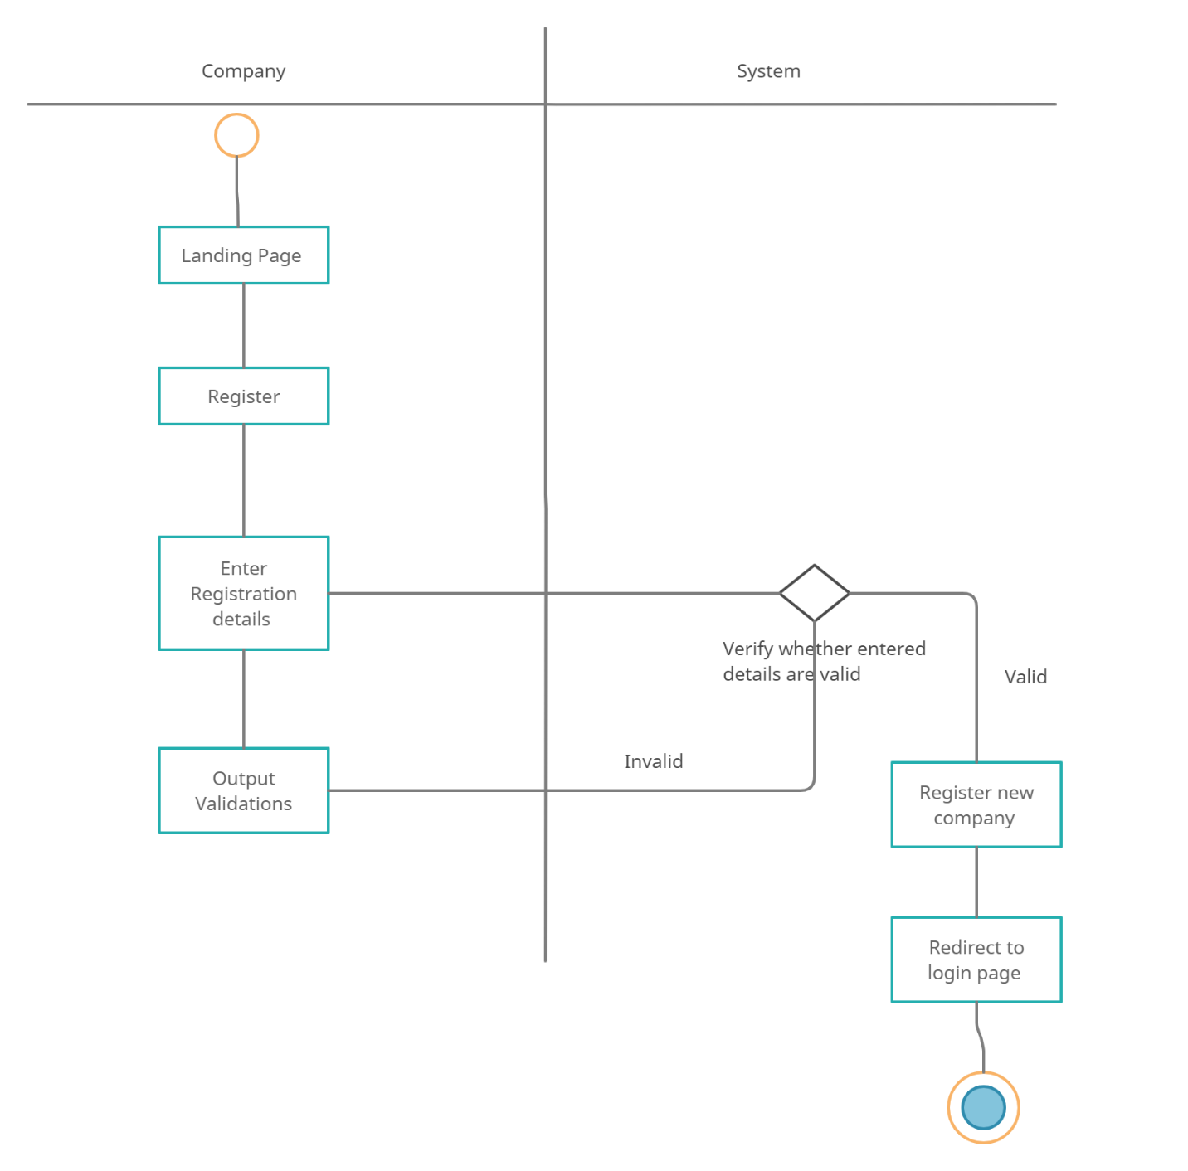

Figure 10. Company Registration Activity Diagram

* For a company to register an account, it is relatively the same process, where they will enter information and account type, which will then be validated by the system and uploaded to the database if no issues persist.

### Company Login Activity Diagram

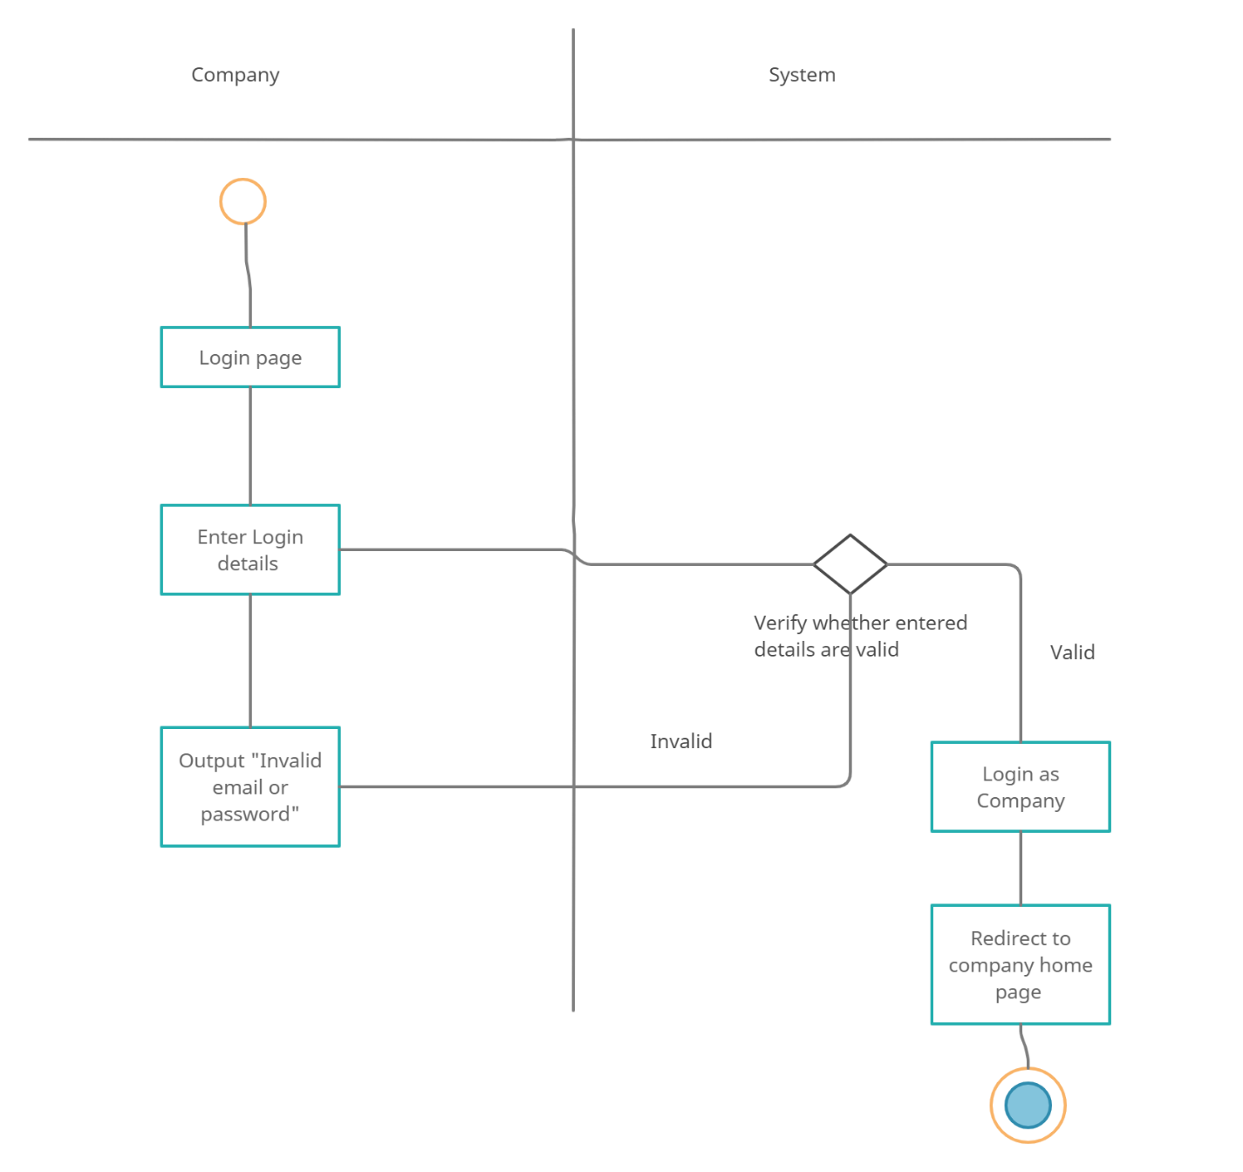

Figure 11. Company Login Activity Diagram

* Once the company individual has registered with an account, they will be able to login and if the information entered is valid, they will be logged in and redirected to the home page.

### Admin Login Activity Diagram

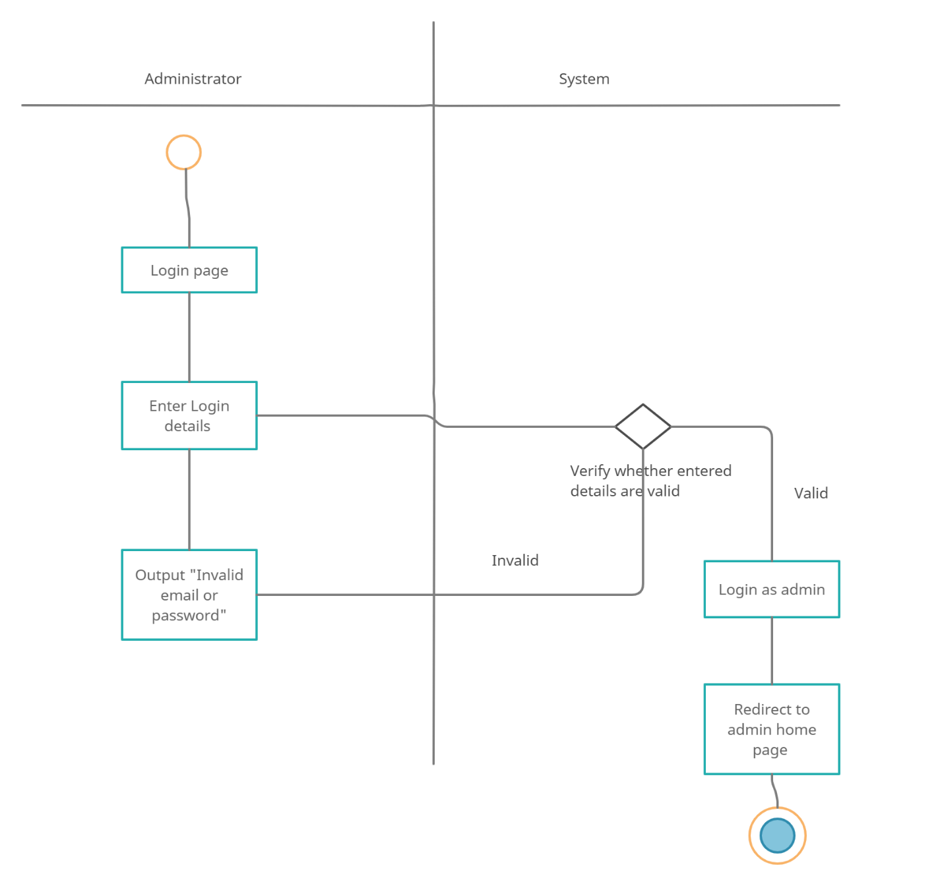

Figure 12. Administrator Login Activity Diagram

* Since an administrator account cannot create an account the way that regular uses do, due to admins having elevated permissions on the website, they will instead enter predetermined information to the website, which will then be validated by the system from the database, and if there is no issue, they will be redirected admin home page.

### Company Delete Job Advert

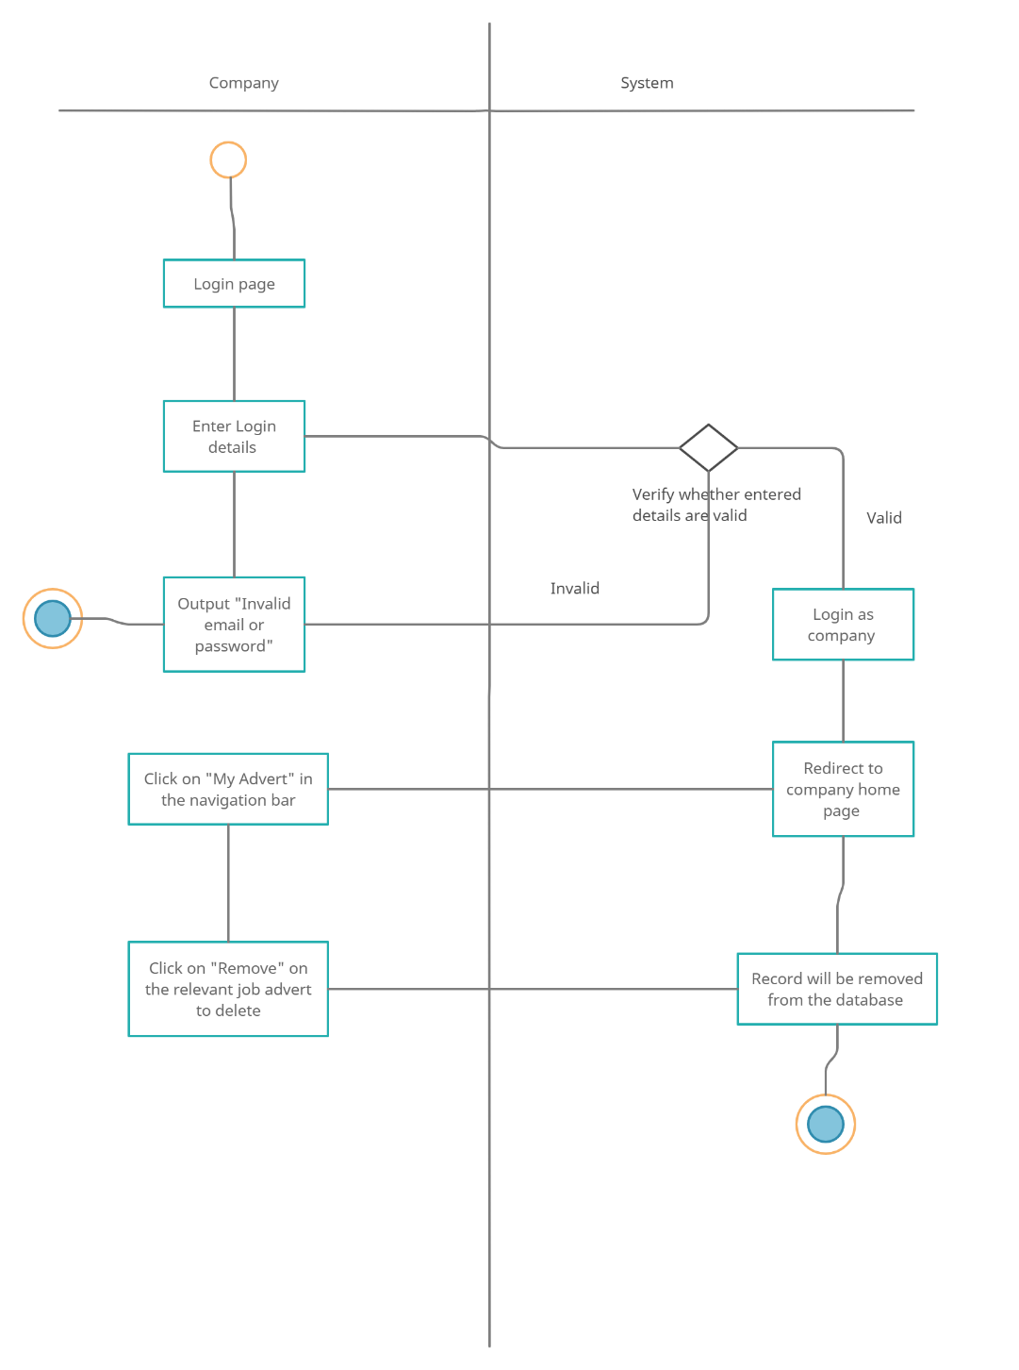

Figure 13. Company Delete Job Advert

* The Company user will be able to view the list of job adverts that they have posted and delete the relevant job advert they desire accordingly by navigating to the ‘My Advert’ button on the navigation bar.

### Company View Adverts

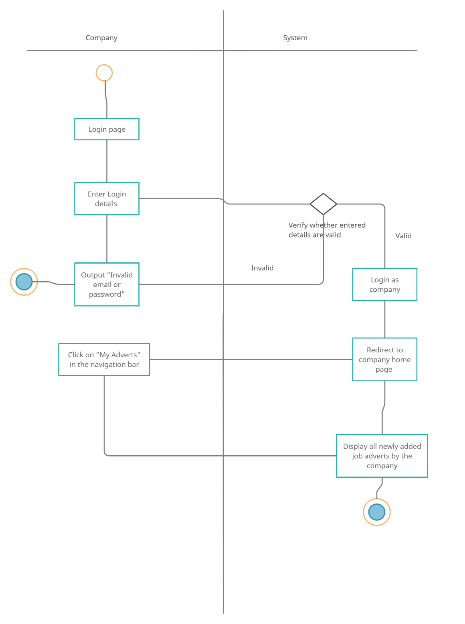

Figure 14. Company View Adverts

* Once the company account user logs into the website they will be able to view the by pressing the “My adverts” button on the navbar.

### Company Add New Job Advert

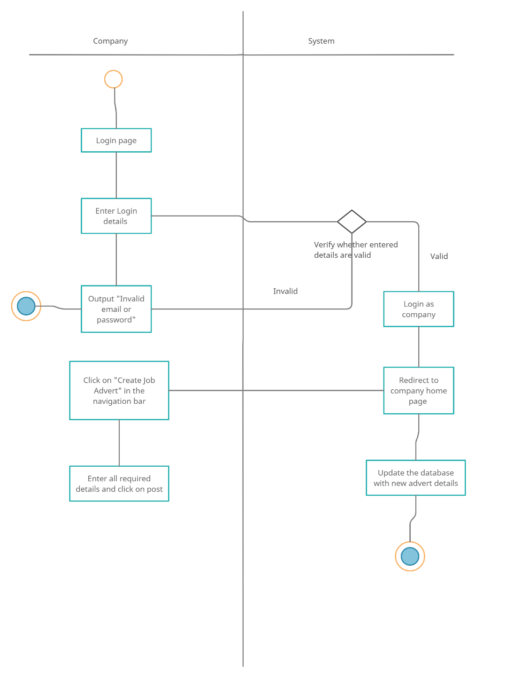

Figure 15. Company Add New Job Advert

* A company account user will be able to add a job listing by pressing the ‘Create job advert’ button on the home nav bar and create enter relevant information regarding the job position. Upon pressing post, it will be uploaded to the database.

### Applicant View Job Advert

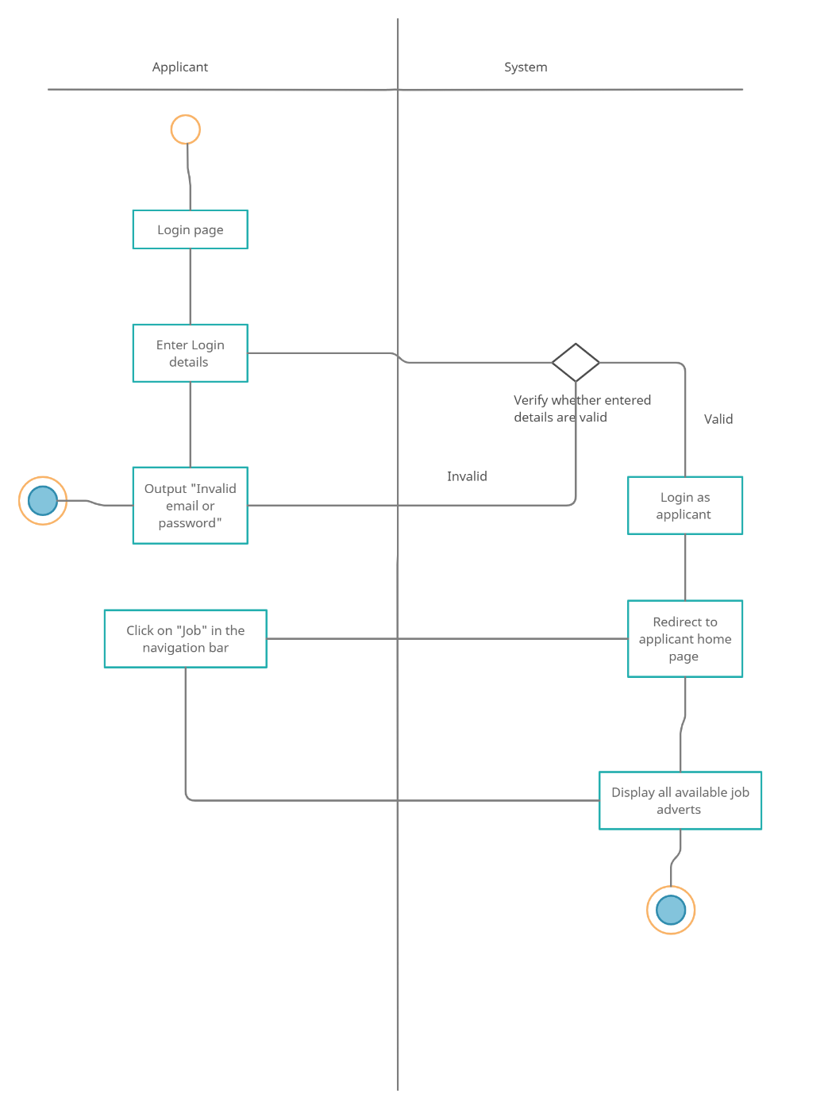

Figure 16. Applicant View Job Advert

* Applicant account will be able to view all available job listings by going to the navbar on their homepage and pressing the ‘Jobs’ button. There they will be able to see all available job adverts and apply to them accordingly.

# Implementation

For the website’s code and its implementation, we utilized the CodeIgniter 4 framework for development as its more robust, shows meaningful error messages and has an abundant feature set for development of the website in future Sprints.

The CodeIgniter 4 framework utilizes the popular MVC (Model, View, Control) design patten. Where the ‘Controller’ handles the logic, ‘View’ the design of the webpage and ‘Model’ the database and deeper information.

For the creation of the initial databases themselves, we utilized the ‘Php Spark’ migration function as provided by CodeIgniter. Running the command “php spark migrate” in the command line of the project folder will automatically create a database in ‘phpMyAdmin’ if XAMPP is running.

*\*\* PLEASE ZOOM INTO THE SCREENSHOTS IF THEY ARE NOT CLEAR INITIALLY \*\**

*~~ File names are mentioned above corresponding screenshots ~~*

## Implementation (Migrations)

Figure 17. Registrations Table Migration

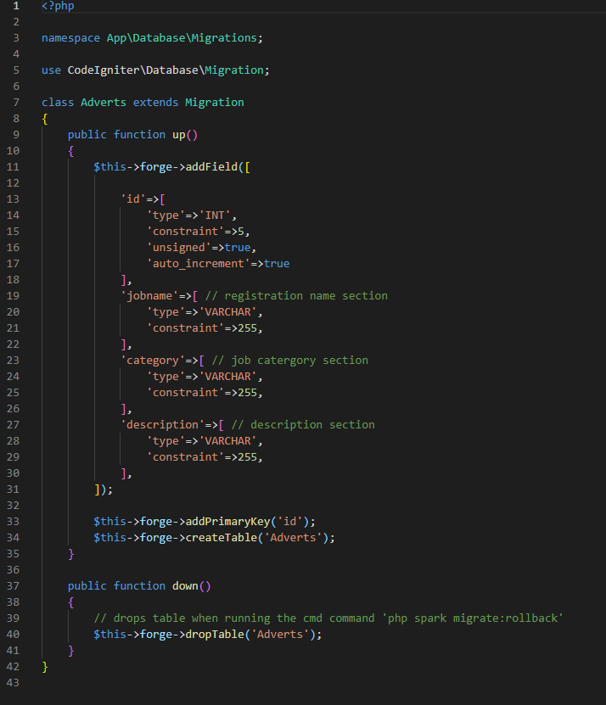

Figure 18. Adverts Table Migration Code

## Implementation (Database Connections)

Specific database connections were used to pull data from the database when necessary.

*DB.php*

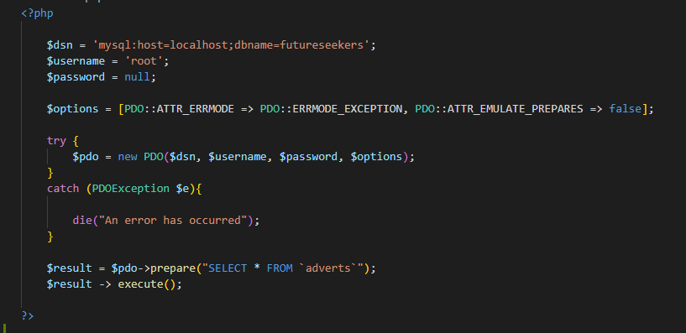

Figure 19. Connection to Adverts Database

*DBuser.php*

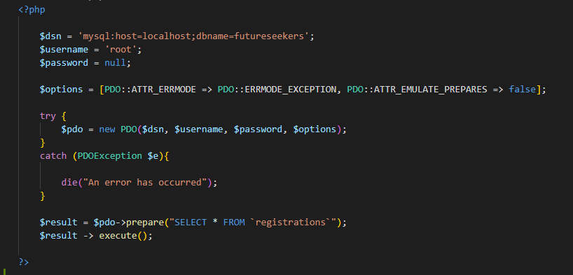

Figure 20. Connection to Registrations Database

## Implementation (Models)

Models will be used to handle database related information passed to it.

*userModel.php*

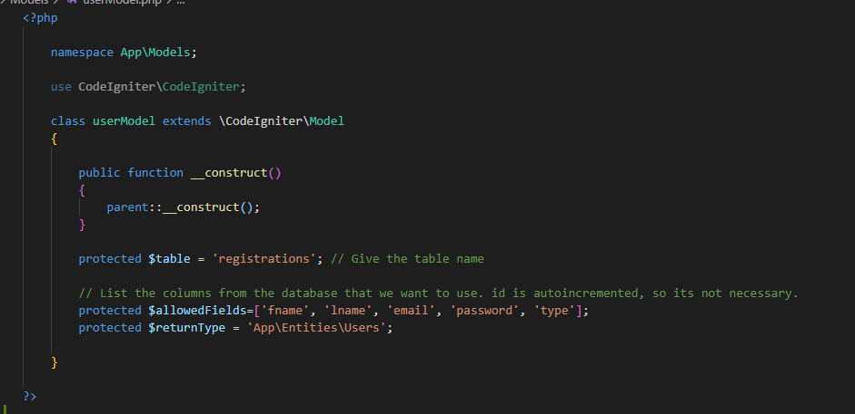

Figure 21. Registrations User Model

*adModel.php*

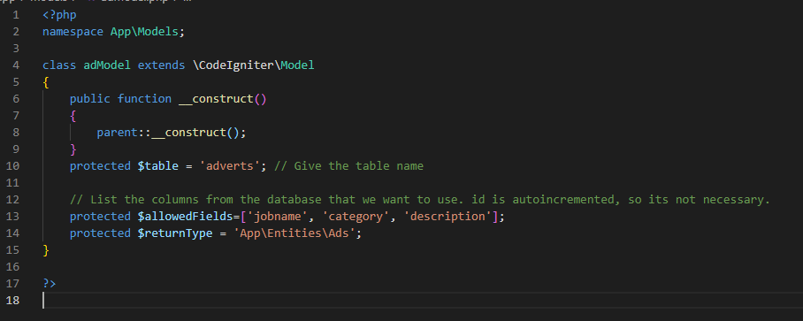

Figure 22. Adverts User Model

## Implementation (Views)

Landing Page where the user will be given the choice to either register or login to the website.

*landing.php*

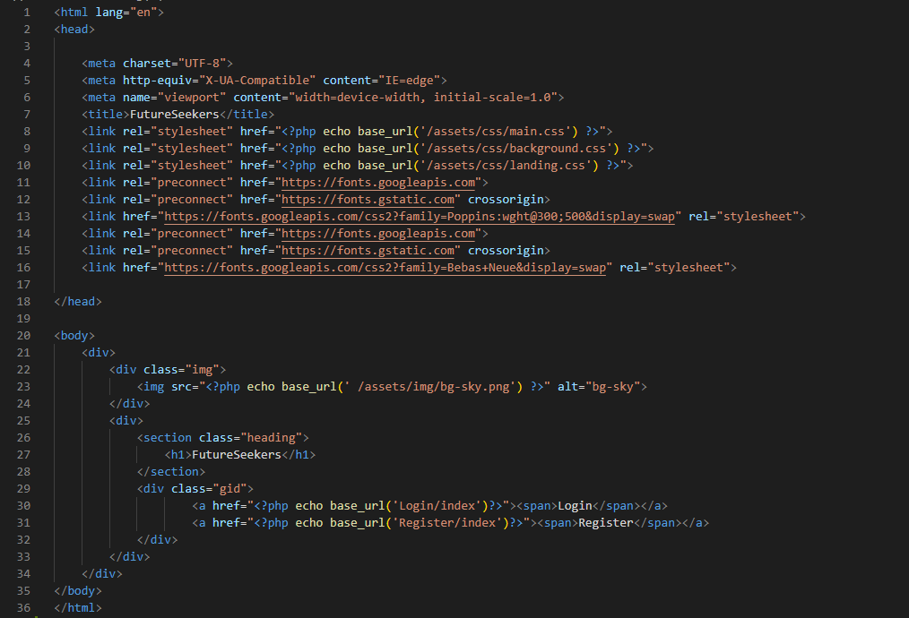

Figure 23. Landing Page Code

Login Page where users will be able to enter their login information to access the website.

*login.php*

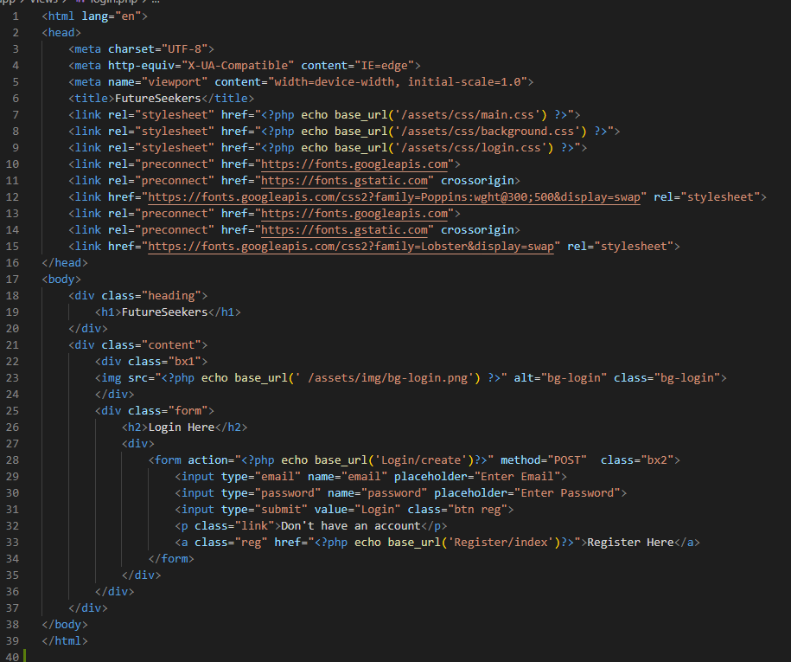

Figure 24. Login Page Code

Registrations page where the user will be able to register with their information and select account type. Which will then be stored in the registrations database.

*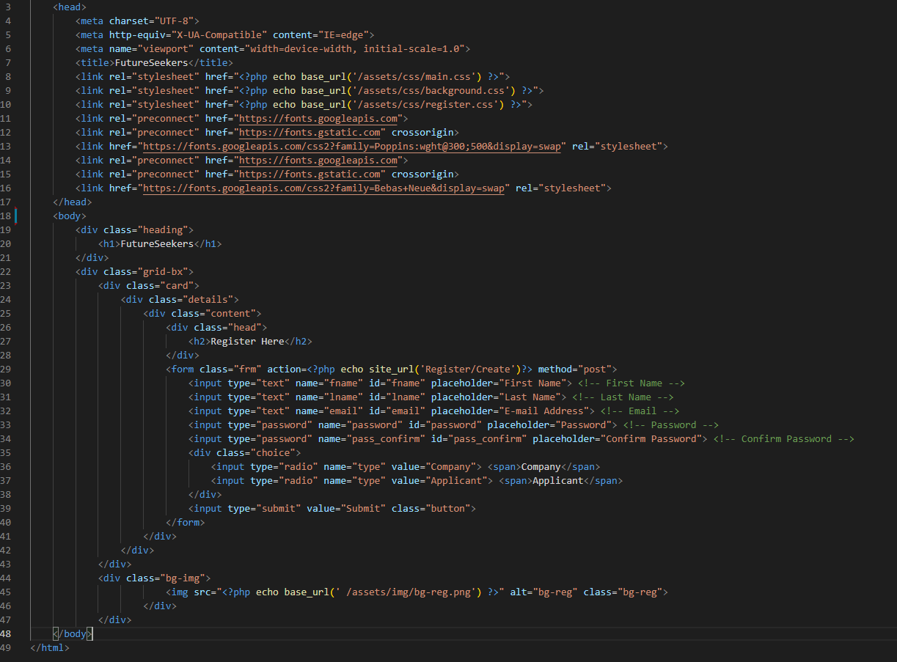register.php*

Figure 25. Registrations Page Code

Applicant home page where the user experience will be tailored to the Applicant.

*Applicant.php*

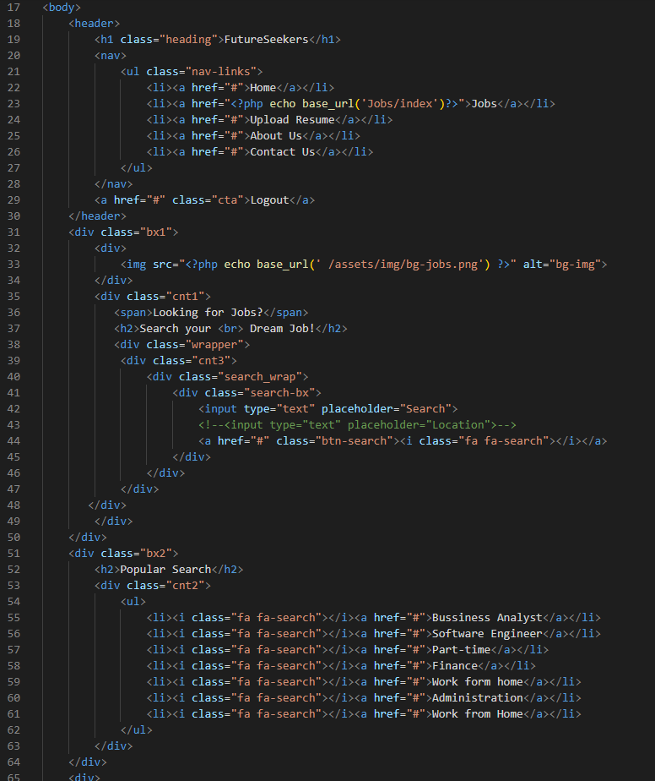

Figure 26. Applicant Home Page Code

Applicant home page will have cards with helpful websites to redirect them when clicked.

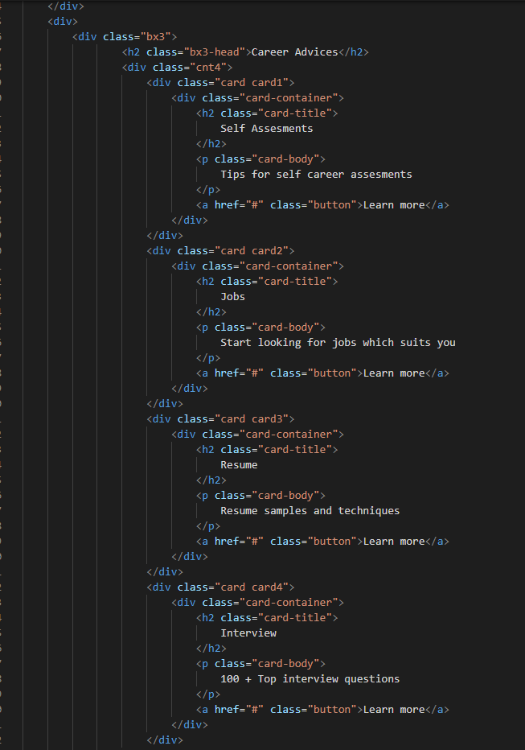

Figure 27. Applicant Home Page Career advice cards

Company home page where the experience is tailored specifically to them.

*Company.php*

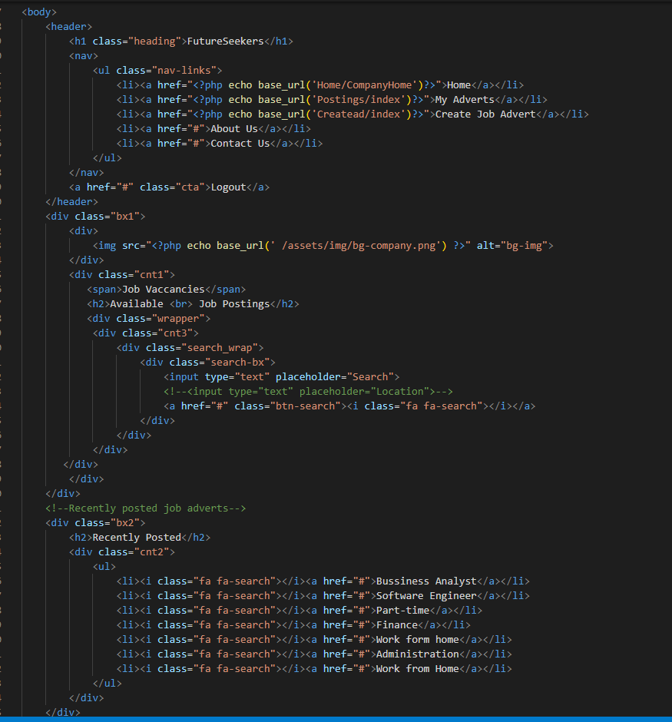

Figure 28. Company Home Page code

Admin home page / dashboard where they will get wider control on what to do with the website. Where they will be able to approve (in future sprint), view users, Job adverts, and generate reports (future sprint).

*Admin.php*

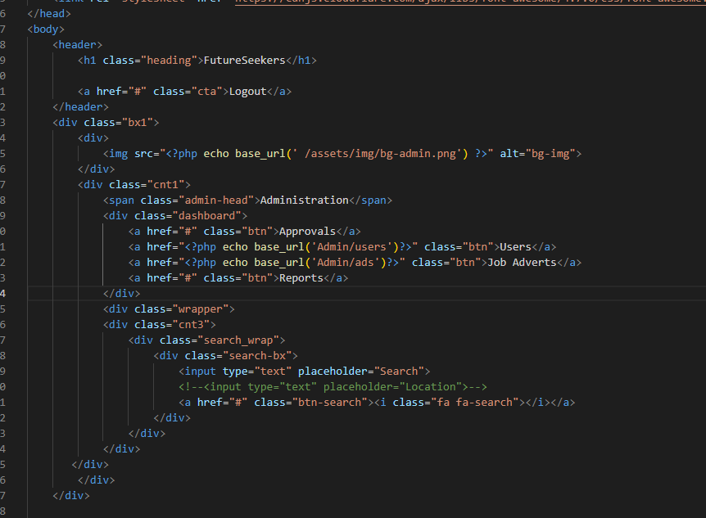

Figure 29. Admin Homepage / Dashboard

Create ad is where users will be able to input data for a job advertisement and set a description for it along with selecting a wide range of categories to set it under. Once posted, it will be saved into the adverts database.

*createad.php*

*(Code snippets in next page)*

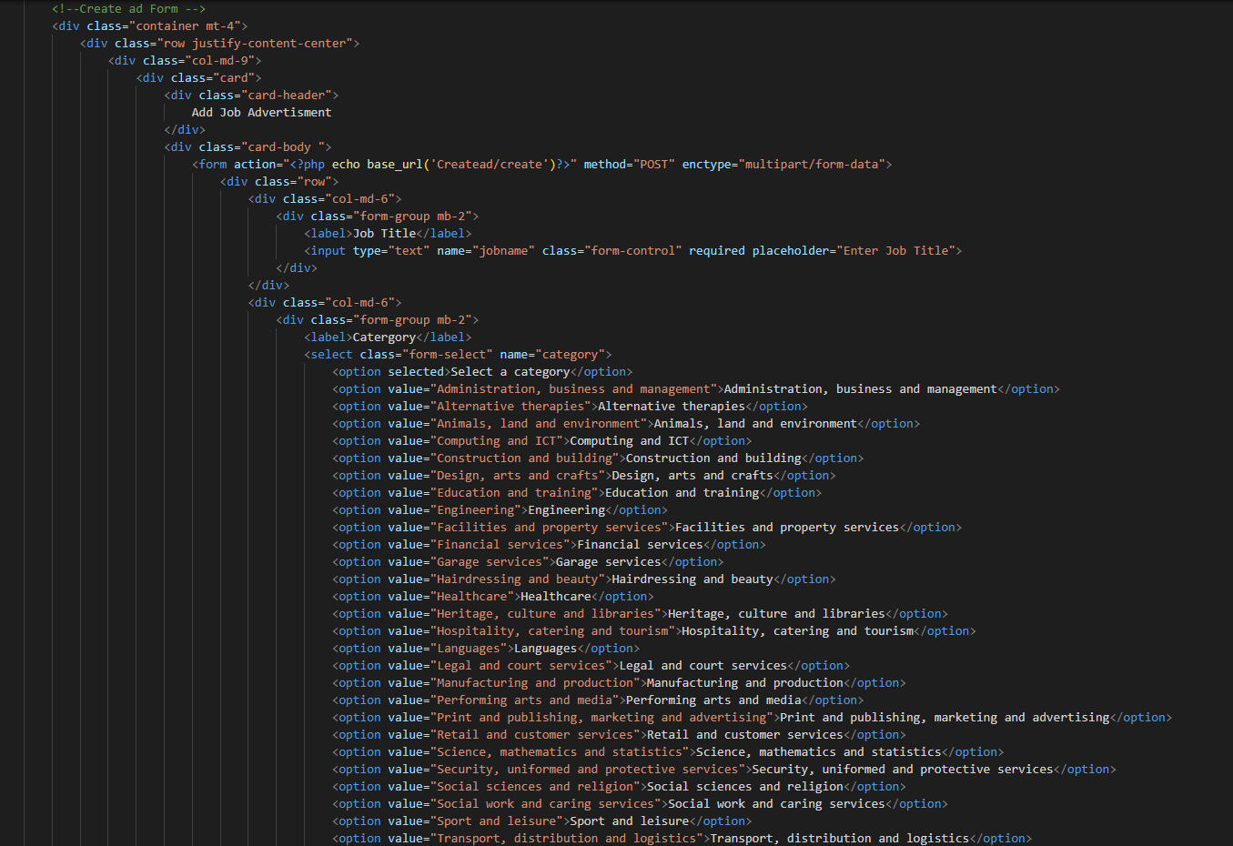

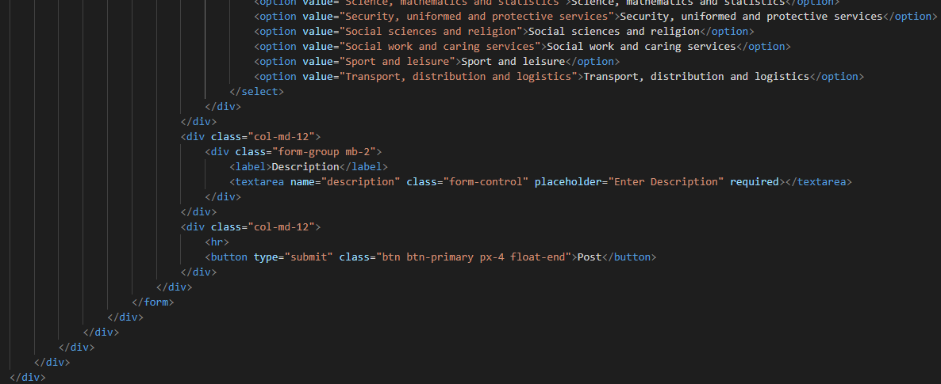

Figure 30. Company Create Adverts

The jobs page is where applicants will be able to view the list of jobs and apply to the ones that they desire. (Apply feature coming in future sprint).

*jobs.php*

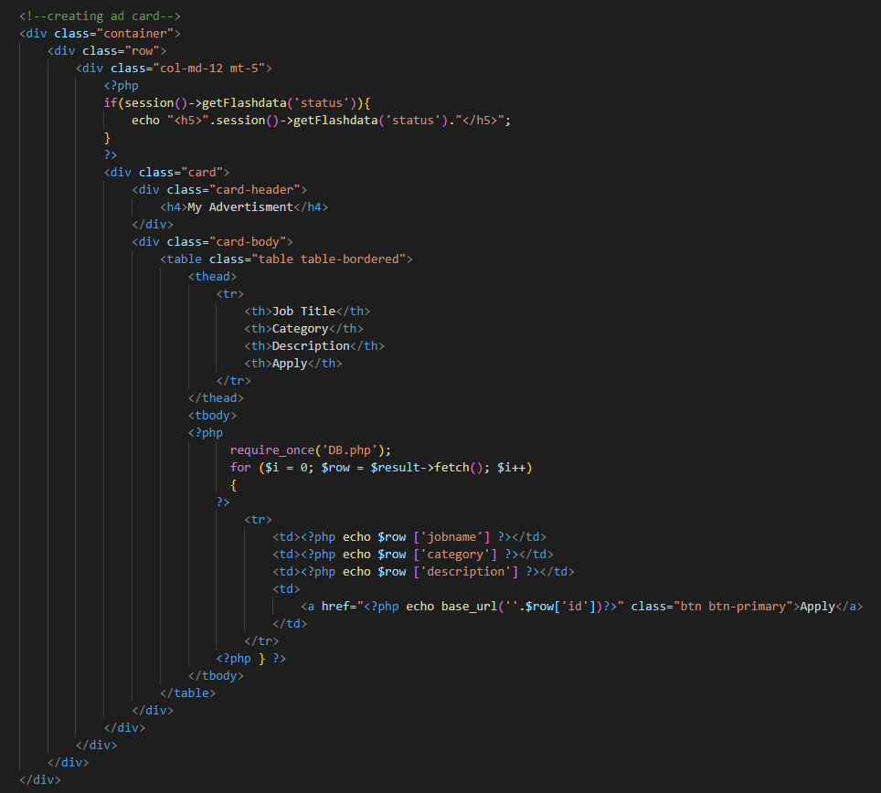

Figure 31. Applicant Jobs Code.

This is where companies will be able to view the job listings that they have posted. (Account specific ads in future sprint).

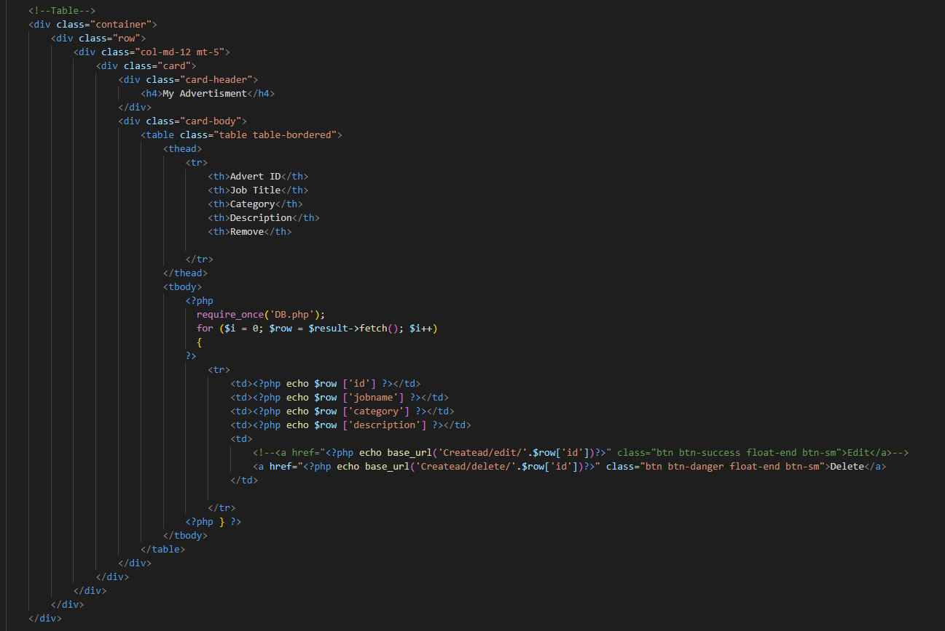*myads.php*

Figure 32. Company View Ads

This is where admins will be able to view all ads on the site and remove them accordingly.

*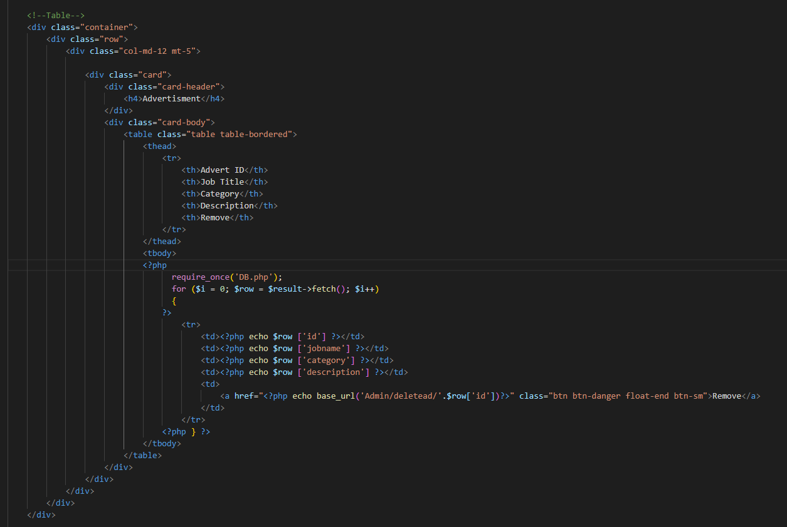adminads.php*

Figure 33. Admin View Ads.

This is where admins will be able to view all registered users on the website and delete them if needed.

*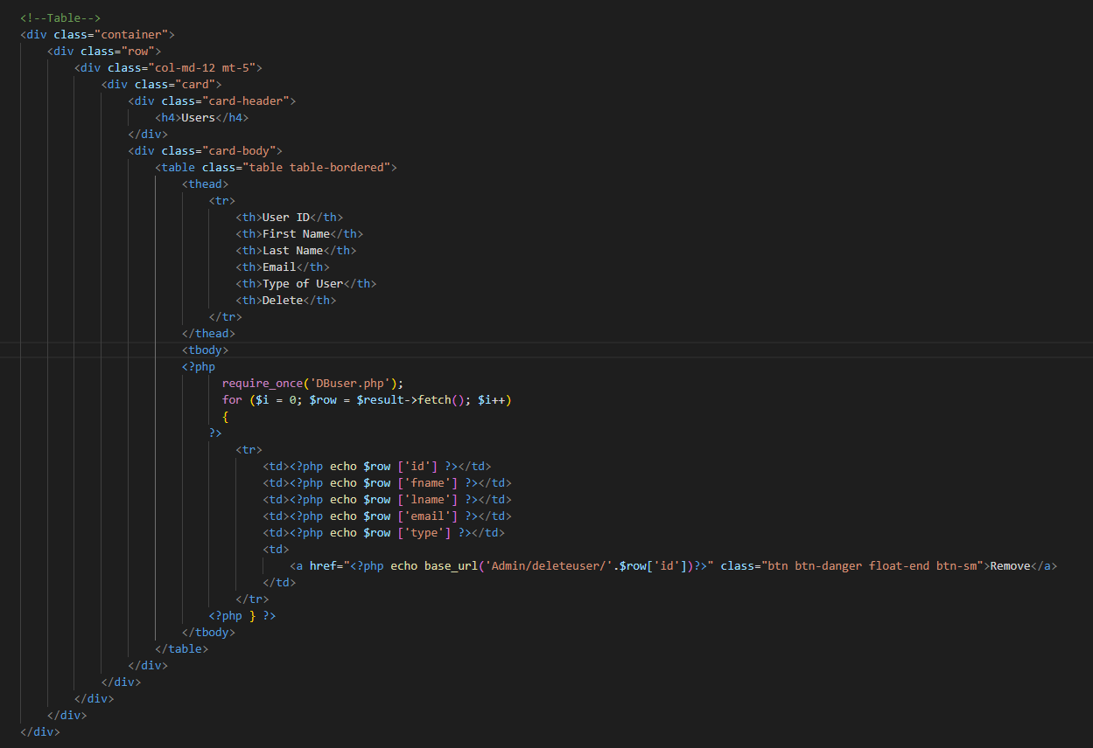adminuser.php*

Figure 34. Admin View All Users.

## Implementation (Controller)

*From this point on will display files that are in the Controllers folder.*

Once the user logs into the site, it will verify if information is correct and then redirect them to a home page based on their account type. A session will be created to keep in track of this.

*Login.php*

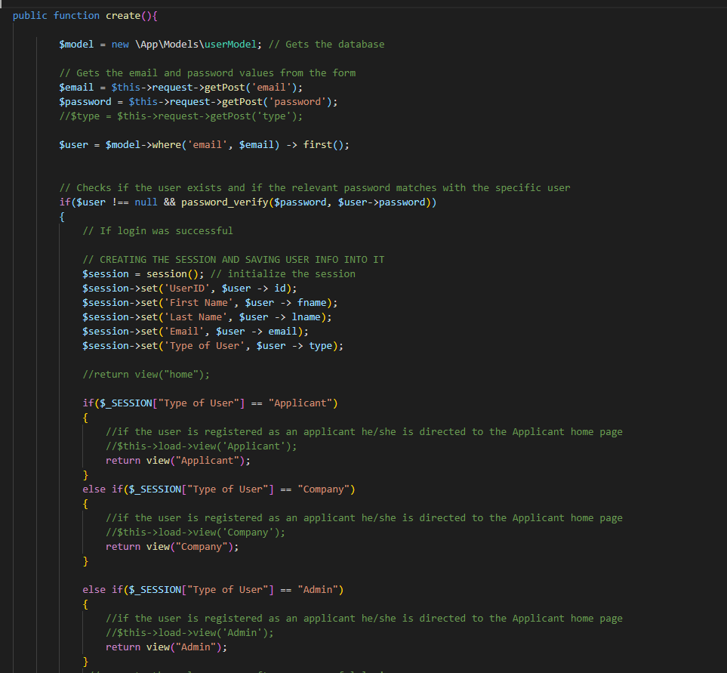

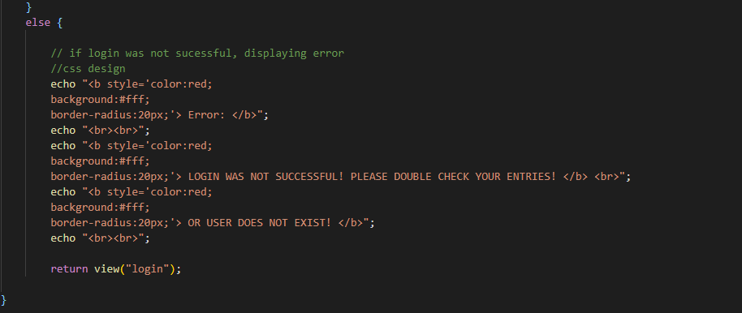

Figure 35. Login Controller

Home controller consists of functions that redirects to relevant homepages when called.

*Home.php*

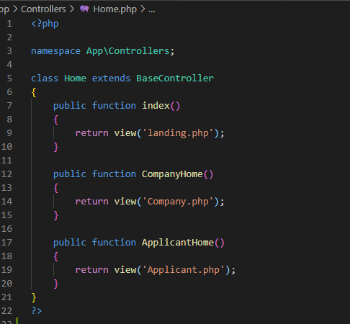

Figure 36. Home Controller

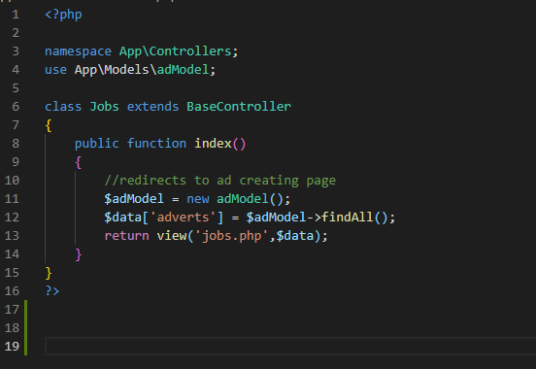

Figure 37. Jobs Controller

When the create function is called it will pull the data from the registrations view and save them in the database if validations are successful and then redirected to the login page. If not, they will be given an error message.

*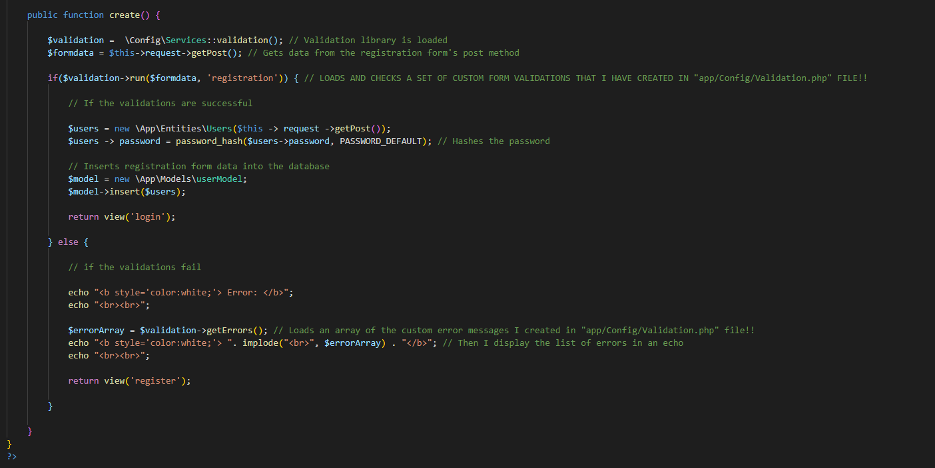Register.php*

*Postings.php*

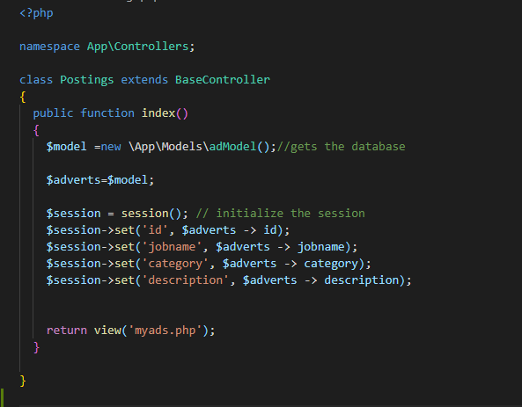

Figure 38. Postings Controller

The create function in the create ad controller file will pull and save the advertisement data that the user enters and saves it in the database.

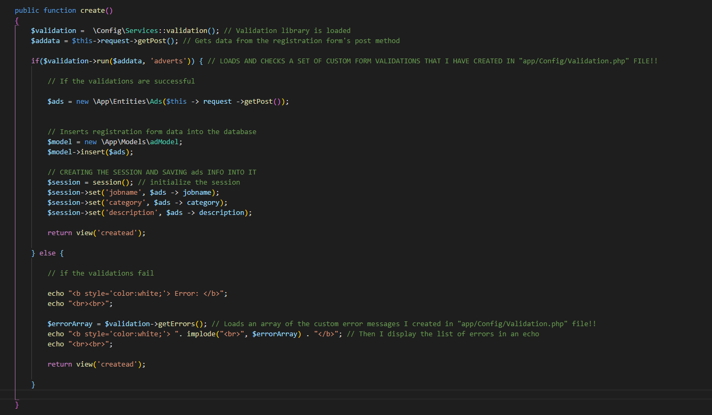*Createad.php*

Figure 39. Createad Controller

The delete function in the createad controller will delete an ad from the database when a specific ad id parameter is sent to it.

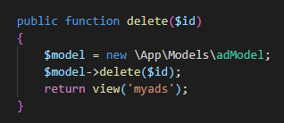

Admin controller file consists of functions that when called, will redirect the user to a specific view.

*Admin.php*

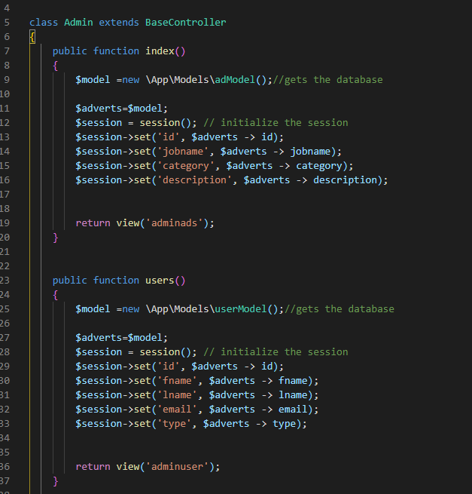

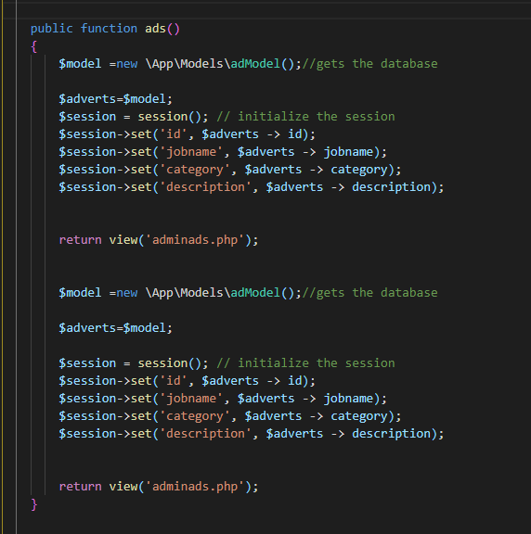

When these functions are called, relevant information based on the database ID will be deleted from the database from the admin.

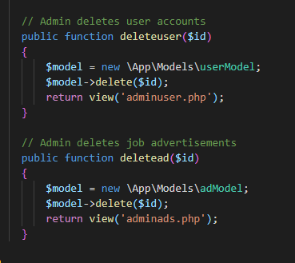

Figure 40. Admin. php

# Interfaces

## Wireframes

### Landing Page

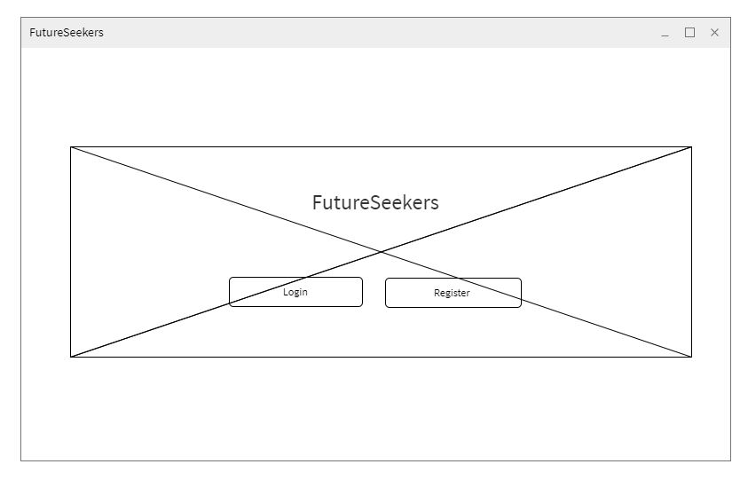

Figure 41. Landing Page (Wireframe)



Figure 42. Landing Page Interface

* With the landing page, the design aspect is mostly tailored towards the two initial choices users will be greeted with once they go to the website. They will be given the choice of either logging in with an existing account or registering a new one.

### Registrations Page

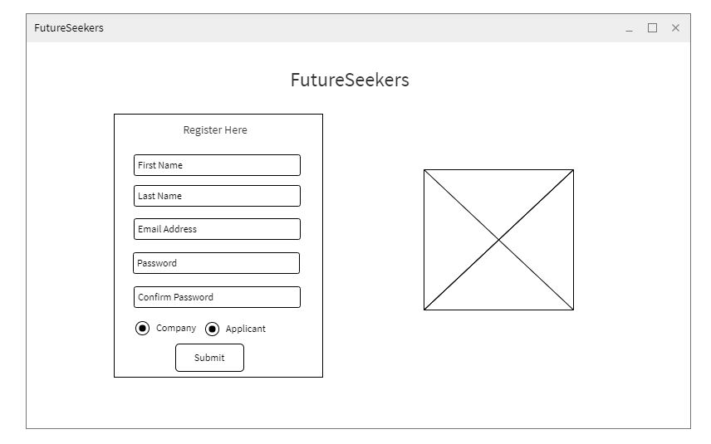

Figure 43. Registration Page (Wireframe)



Figure 44. Registrations Page Interface

* For the user to use the Futureseekers website and its features, the user needs to be registered with an account. For this, after selecting register in the landing page, the user will be redirected to the registrations page where they will be asked for necessary information to create an account, and then categorize their account either as a ‘Company’ or an ‘Applicant’.

### Login Page

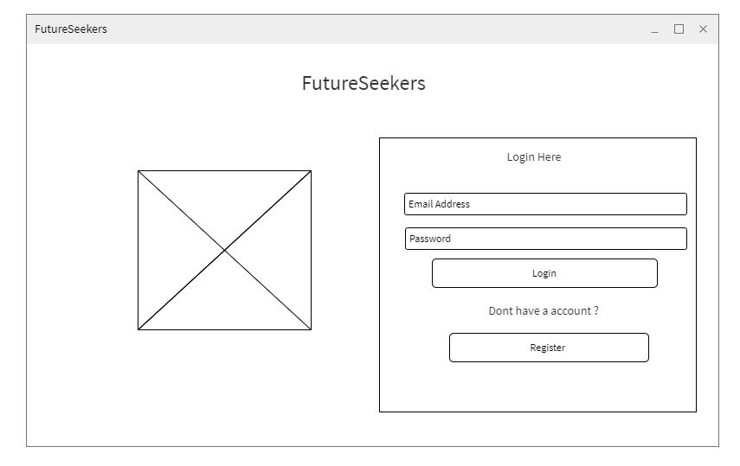

Figure 45. Login Page (Wireframe)

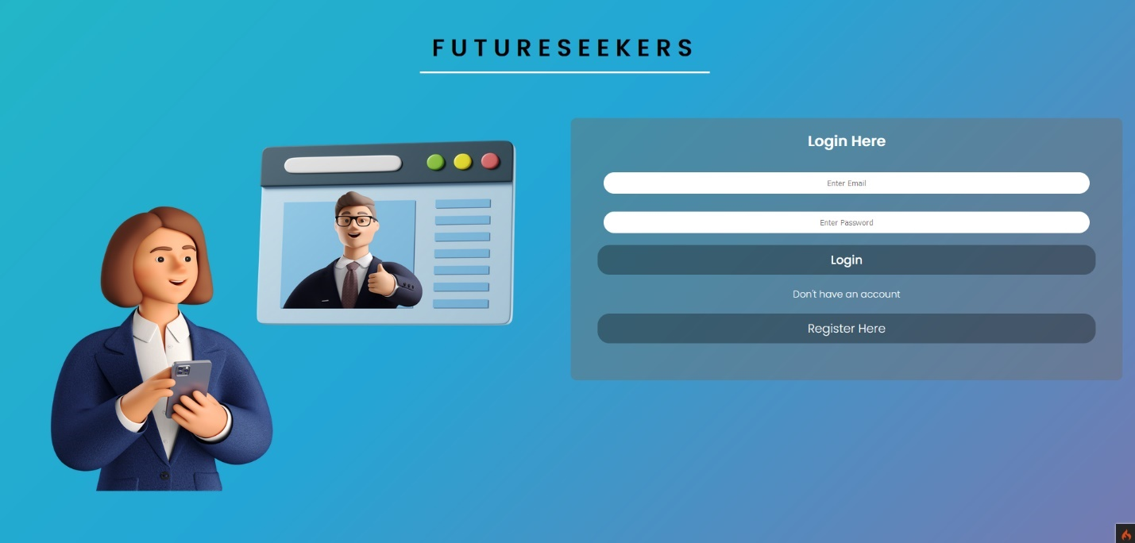

Figure 46. Login Page Interface

* Once the user has registered with an account, or already has one existing, they will be able to go to the login page and enter their login email address and password for the website. Once entered, they will be redirected to the home page.

### Applicant Home Page

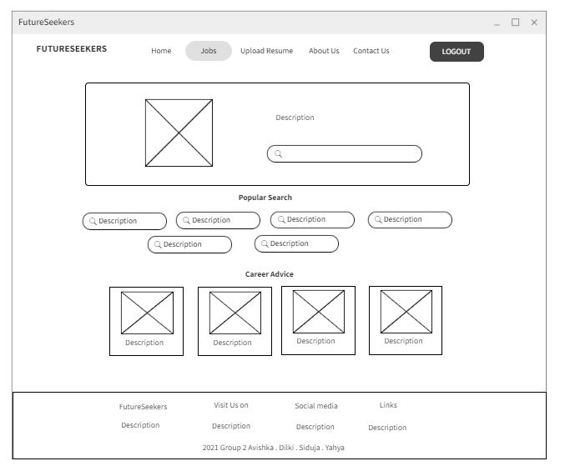

Figure 47. Applicant Home Page (Wireframe)

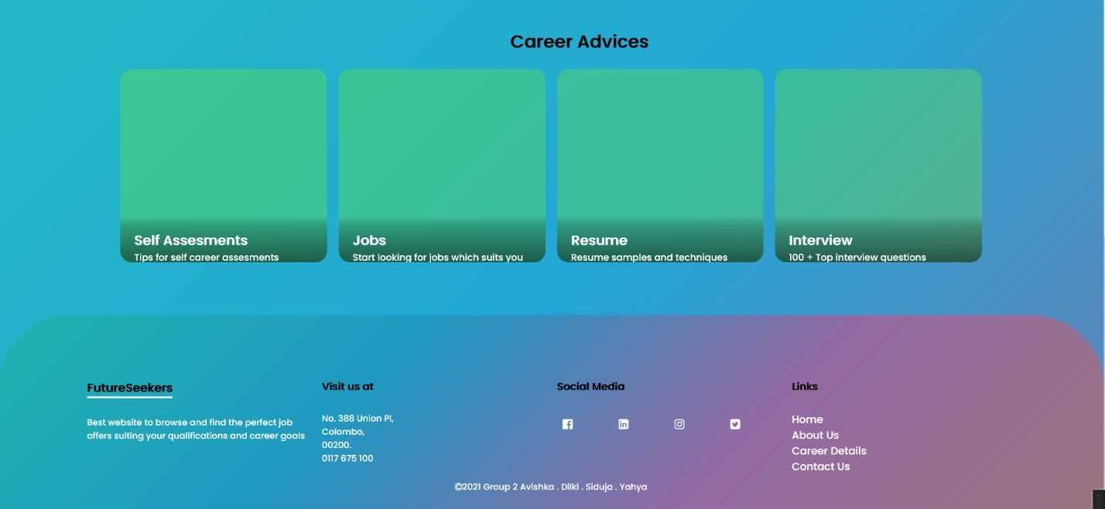

Figure 48. Applicant Home Page Interface

* If the user that logged into the website is classified as an ‘Applicant’ user, the home page they will be redirected to will display information and features specifically tailored to them. Mainly searching the option for searching for jobs advertisements.

### Company Home Page

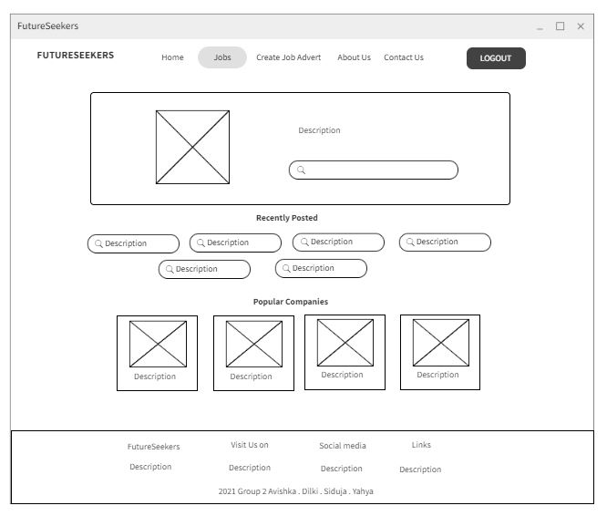

Figure 49. Company Home Page (Wireframe)

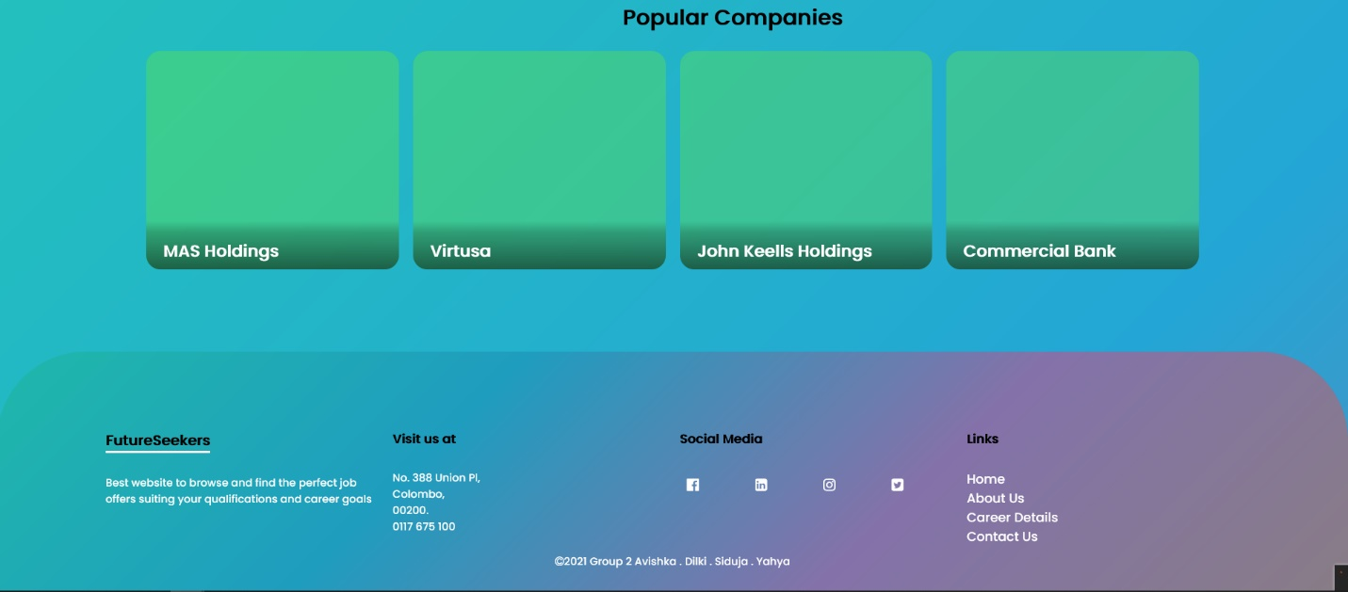

Figure 50. Company Home Page Interface

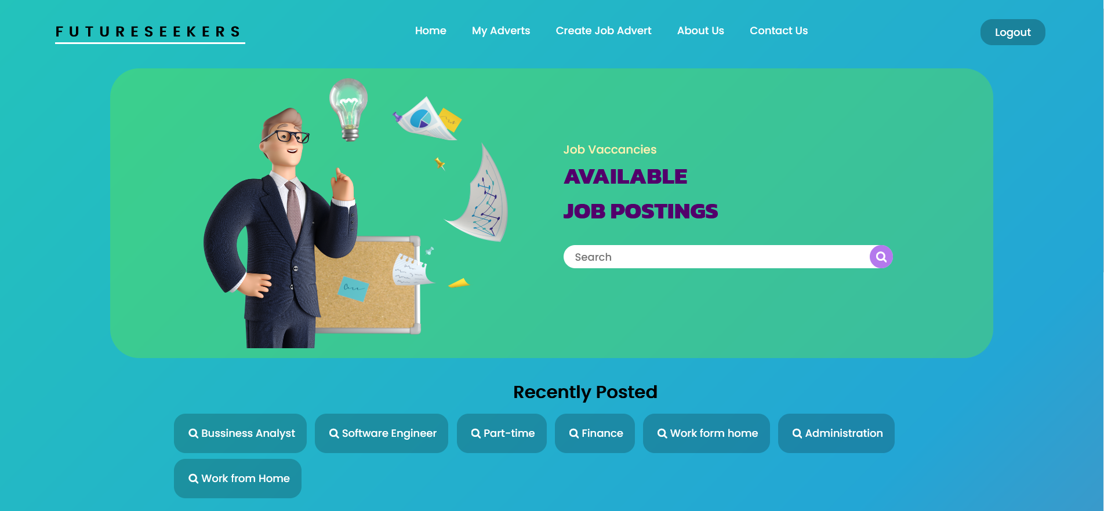

* If the logged in user is with an account type of ‘Company’, they will be redirected to a home page and will display information and features specifically tailored to them.

### Admin Home Page

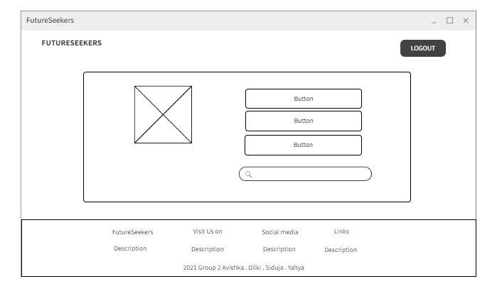

Figure 51. Admin Home Page (Wireframe)

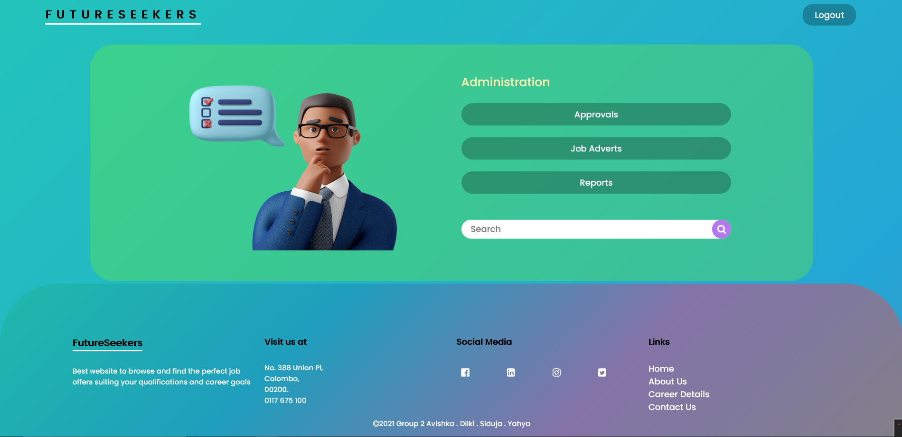

Figure 52. Admin Home Page Interface

* If the user that logged in is an Admin, they will be greeted with a dashboard, for posting, approvals and reports generation based on the website’s advertisement-based information.

### Company View Advert

### 

Figure 53. Company View Advertisement (Wireframe)

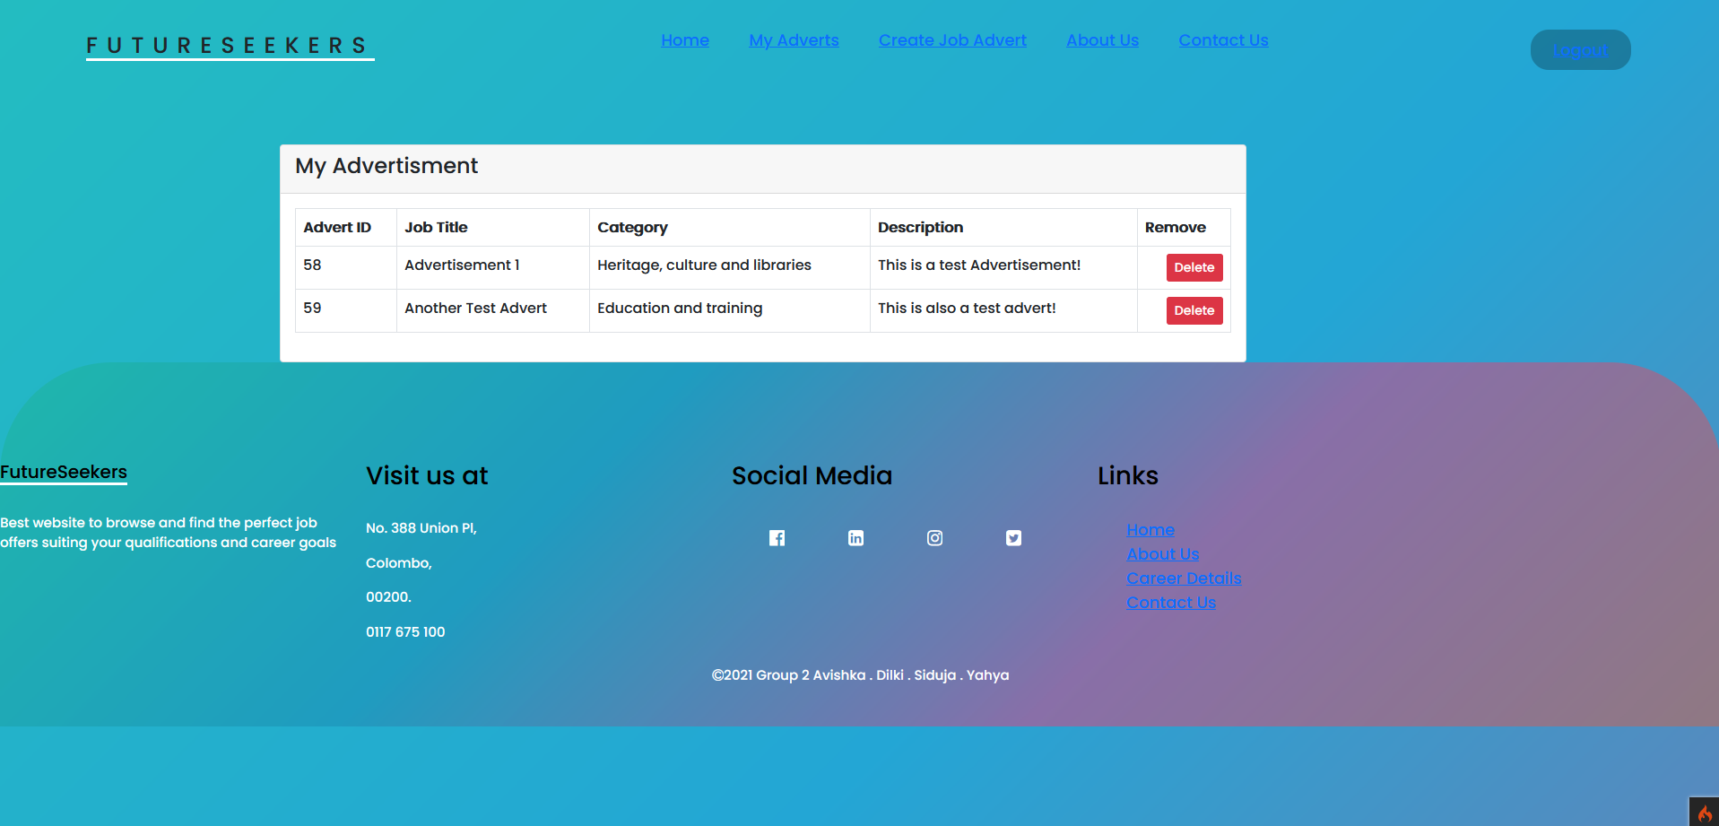

Figure 54. Company View Job Advertisement Interface

* Once jobs have been posted by the company, they will be able to view it all in the My adverts screen where all of it will be listed down in a table with the option to delete them.

### Company Create Job Advertisement

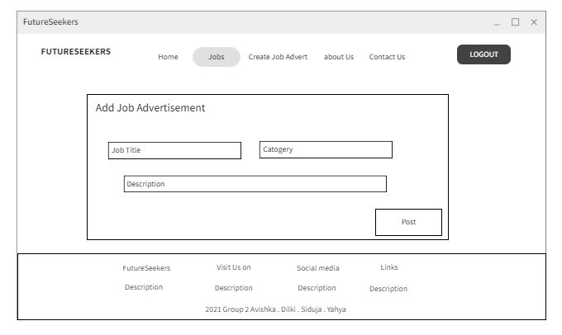

Figure 55. Company Create Job Advertisement (Wireframe)

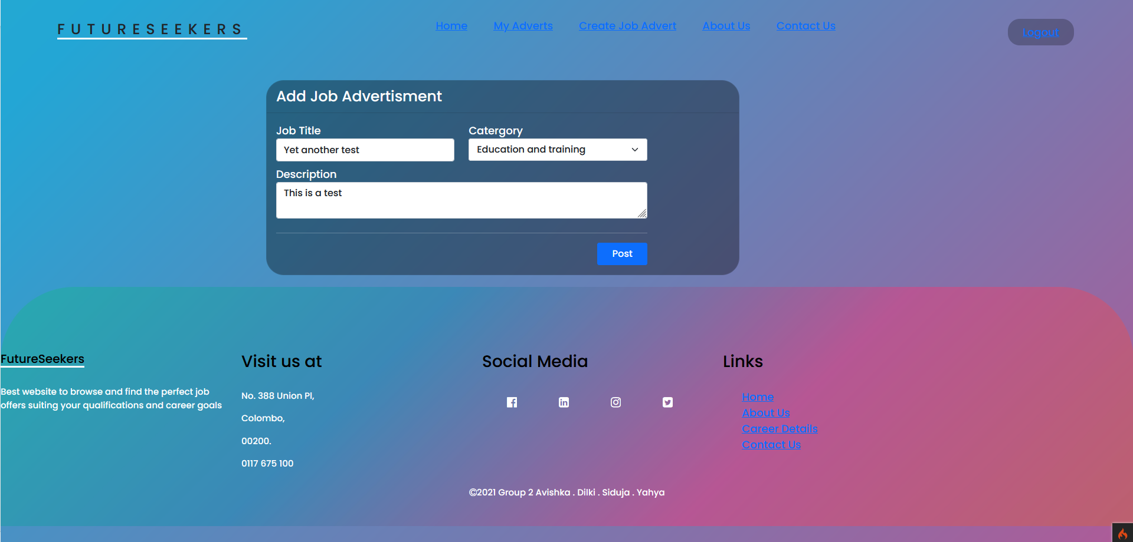

Figure 56. Company Create Job advertisements Interface

* In this page, companies will be able to set a title for their job advertisement and set a category to it. Along with that they can set a description to be more informative to other users.

### Applicant Jobs View Page

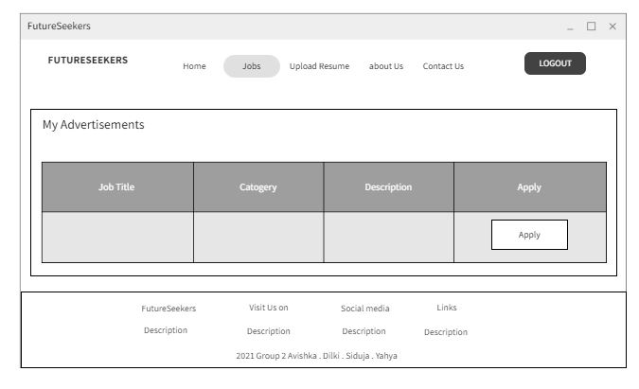

Figure 57. Applicant Jobs View Page (Wireframe)

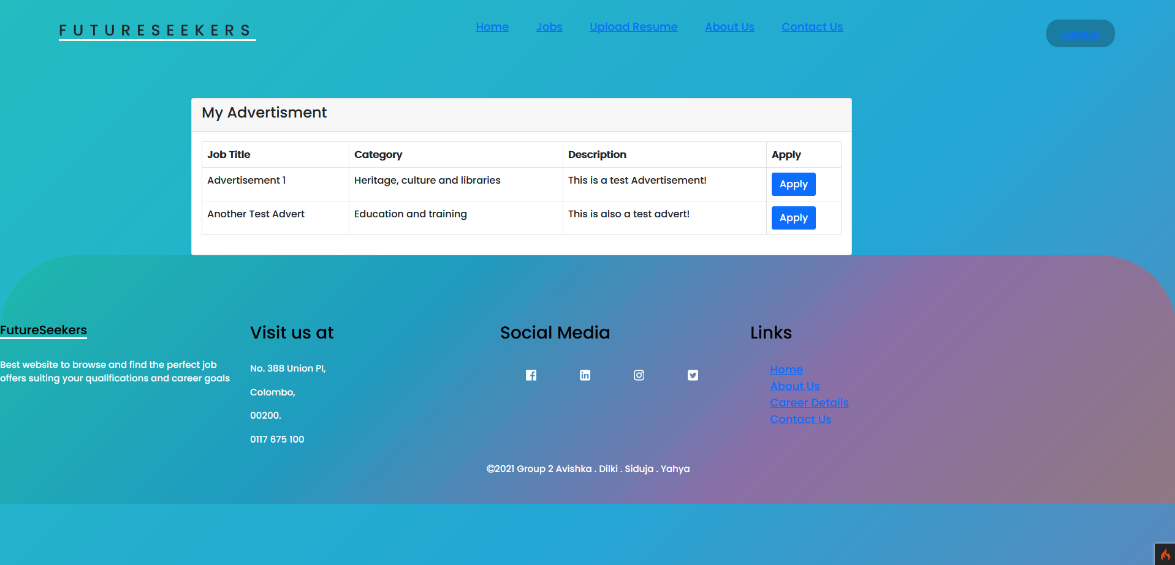

Figure 58. Applicant Jobs View Page Interface

* Here an applicant will be able to get a broad view of all job listings that are available on the website that are posted by companies. It will display a title; the category and description and applicants will be able to apply to them (apply feature will be implemented in a future Sprint).

# Test Cases

|  |  |  |  |  |  |  |  |
| --- | --- | --- | --- | --- | --- | --- | --- |
| **Test case**  **ID** | **Description** | **Pre-condition** | **Test Procedure** | **Test Inputs** | **Expected Outcome** | **Actual Outcome** | **Result** |
| TC001 | Registration button function | Customer should be in the landing page. | Customer clicks on the “Register” button | Button Click “Login” | Customer will be redirected to the Registration page | Customer was redirected to the registration page. | PASS |
| TC002 | Login button function | Customer should be in the landing page. | Customer clicks on the “Login” button | Button Click “Register” | Customer will be redirected to the Login page | Customer was redirected to the login page. | PASS |
| TC003 | Customer enters  registering credentials | Customer should be able to view the registration page | Customer enters the registration details and press “register” | Button Click “Register” | Customer will be redirected back to the Login page | Customer was successfully directed to the Login page | PASS |
| TC004 | Customer should be able to login as an applicant with valid login details | Customer should enter the system if entered details are valid. | Customer enters the user’s email and password and clicks “log in” | Button Click “Login” | Applicant should be directed to the applicant home page | Customer was directed to the applicant home page | PASS |
| TC005 | Customer should be able to login as a company with valid login details | Customer should enter the system if entered details are valid. | Customer enters the user’s email and password and clicks “log in” | Button Click “Login” | Company should be directed to the company home page | Customer was directed to the company home page | PASS |
| TC006 | An error should occur when the customer enters wrong login details | Customer should not be able to enter the system | Customer enters the user’s email and password and clicks “log in” | Button Click “Login” | Display error message “Login was not successful! Please double check your entries! Or User does not exist” | Displayed error message “Login was not successful! Please double check your entries! Or User does not exist” | PASS |
| TC007 | A message will be displayed if the customer misses a section | Customer should not be able to register if details are missing in some sections. | Customer enters registration credentials except the first name. | Button Click “Register” | Display error message “First name section is required” | Displayed error message “First name section is required” | PASS |
| TC008 | A message will be displayed if the user misses a section | Customer should not be able to register if details are missing in some sections. | Customer enters registration credentials except the last name. | Button Click “Register” | Display error message “Last name section is required” | Displayed error message “Last name section is required” | PASS |
| TC009 | A message will be displayed if the user misses a section | Customer should not be able to register if details are missing in some sections. | Customer enters registration credentials except the Email. | Button Click “Register” | Display error message “The email section is required” | Displayed error message “The email section is required” | PASS |
| TC010 | Company and Applicant Check box | Customer should be able to view the registration page | Customer will have to select either company or Applicant | Button Click “Register” | Display error message “Select the required check box” | No error message was displayed | FAIL |
| TC011 | A message will be displayed if the user misses a section | Customer should not be able to register if details are missing in some sections. | User enters registration credentials except the Password. | Button Click “Register” | Display error message “The password section is required” | Displayed error message “The password section is required” | PASS |
| TC012 | A message will be displayed if the user misses a section | Customer should not be able to register if details are missing in some sections. | User enters registration credentials without confirming the password. | Button Click “Register” | Display error message “The pass_confirm field is required.” | Displayed error message “The pass_confirm field is required” | PASS |
| **Company Home Page** | | | | | | | |
| TC013 | Navigation Create job advert Function | User should be signed in as a company | User clicks the Job Advertisement Page from the Navigation Bar | Button Click “Create Job Adverts” | User will be directed to the “Add Job Advertisement” Page | User was directed to the “Add Job Advertisement” Page | PASS |
| TC014 | Navigation My adverts function | User should be signed in as a company | User clicks My Advertisement Page from the Navigation Bar | Button Click “My Adverts” | User will be directed to the “My Advertisement” Page | User was directed to the “My Advertisement” Page | PASS |
| TC015 | User should be able to post a company job advert | User should be signed in as a company | User enters the relevant details on the company job advertisement | Button Click “Post” | User will be directed to the “My Advertisement” Page | User was directed to the “My Advertisement” Page | PASS |
| TC016 | User should be able to delete a company job advert | User should be signed in as a company and should be in my advertisement page | User clicks on the “Delete” button | Button Click “Delete” | Company job advert should be deleted | Company job advert was deleted | PASS |
| TC017 | Navigation Home button | Company user should be in the Jobs page | User clicks on the “Home” button | Button Click “Home” | Company user will be redirected to the company home page | Company User was redirected to the company home page | PASS |
| TC018 | A message will be displayed if the user misses a section | Company user should not be able to register if details are missing in some sections. | Company enters relevant details without the job title. | Button Click “Post” | Display error message “Please fill out this field” | Displayed error message “Please fill out this field” | PASS |
| TC019 | A message will be displayed if the user misses a section | Company user should not be able to register if details are missing in some sections. | Company enters relevant details without the job description. | Button Click “Post” | Display error message “Please fill out this field” | Displayed error message “Please fill out this field” | PASS |
| TC020 | A message will be displayed if the user misses a section | Company user should not be able to register if details are missing in some sections. | Company enters relevant details without the job category. | Button Click “Post” | Display error message “Please fill out this field” | No error message was displayed | PASS |
| TC021 | Redirecting company users from homepage to popular company profiles | Company user should be signed in as a company | Company user clicks “Learn more” button | Button Click “Learn More” | Company user will be redirected to the MAS Holdings company home page | Company user was redirected successfully to the MAS Holdings home page | PASS |
| TC022 | Redirecting company users from homepage to popular company profiles | Company user should be signed in as a company | Company user clicks “Learn more” button | Button Click “Learn More” | Company user will be redirected to the Virtusa company home page | Company user was redirected successfully to Virtusa home page | PASS |
| TC023 | Redirecting company users from homepage to popular company profiles | Company user should be signed in as a company | Company user clicks “Learn more” button | Button Click “Learn More” | Company user will be redirected to the John Keells company home page | Company user was redirected successfully to John Keells home page | PASS |
| TC024 | Redirecting company users from homepage to popular company profiles | Company user should be signed in as a company | Company user clicks “Learn more” button | Button Click “Learn More” | Company user will be redirected to the Commercial Bank company home page | Company user was redirected successfully to Commercial Bank home page | PASS |
| **Applicant Home Page** | | | | | | | |
| TC025 | Navigation “Jobs” function | Applicant should be signed in as an applicant | Applicant clicks “Jobs” from the Navigation Bar | Button Click “Jobs” | Applicant will be directed to the “My Advertisement” Page | Applicant was directed to the “My Advertisement” Page | PASS |
| TC026 | Navigation Home button | Applicant should be in the Jobs page | applicant clicks “Home” button | Button Click “Home” | Applicant will be redirected to the applicant home page | Applicant was redirected to the applicant home page | PASS |

# Sprint 1 Retrospective

## Avishka Senanayake (Sprint 1 Retrospective) – SCRUM Master

For this assignment, we conducted frequent Scrum meetings to discuss tasks, clarifications, and issues and even in between some conflict resolution. During this Sprint I learned the importance of time management from a Scrum master perspective as it is imperative to get as much out of a project as possible with the given timelines and goals. I got to further understand the importance of the role that each type of Agile team member plays in a professional environment to bring a project to fruition.

The mitigation towards future Sprints and personal development will have to be towards better time management and researching before executing a task given at hand. As unexpected bugs and issues might arise, causing the tasks to be delayed further due to our inexperience.

Further, early documentation and keeping up with the planning more frequently is an added must as losing track of a task might cause another team member’s task to be delayed or held as it is dependent on mine.

As for teamwork everyone pulled their weight in the end and gave assistance towards the development of the website itself with minor bugs and issues. Communication was well kept an in an Agile environment, this is what is needed.

## Siduja Perera (Sprint 1 Retrospective) – Quality Assurance

In this retrospective of the Sprint, it helped us a lot as we worked as a team to solve problems and improve productivity. We had frequent scrum meetings. We helped the developer who had more work than the others. I learned about time management and team building. It also gave equal powers to all members to open and give their views. As the work was divided among all members, we were able to reach the end with the support of all members.

## Mohammad Yahya (Sprint 1 Retrospective) - Developer

During this sprint at the beginning, we had a falling of the team then we held up a meeting and communicated within ourselves and came to a reasonable solution. We had regular scrum meetings and meetings in between where we helped each other with their issues. As the developer of this sprint, I faced many challenges coding which I shared with my colleagues and fixed them. Personally, this sprint taught me a lot from time management, prioritization team building and a lot more.

## Dilki Delgoda (Sprint 1 Retrospective) – Business Analyst

All my teammates worked equally hard and was able to successfully complete the requirements which were needed for the first sprint. We had frequent scrum meetings which helped us monitor our progress. The most challenging area would have been the development of the product as there were areas which some members lacked the coding knowledge.

# References

* Agilest. 2021. *Agile budgeting: How much will it cost? | Agilest*. [online] Available at: <https://www.agilest.org/agile-project-management/budgeting/> [Accessed 15 November 2021].